Design to Succeed in
LEGO WeDo Robotics
Challenges
An Enrichment Unit for Ages 7 to 10

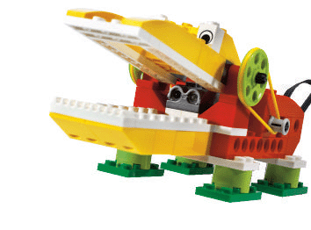
By Steve Coxon
http://stevecoxon.com
coxonsteve@hotmail.com
2010

This unit is free to use, distribute, copy, expand, and revise for non-profit educational purposes so long as it maintains my name and contact information. I greatly enjoy hearing where and how my free units are utilized.
Table of Contents
3 Purpose
4 Unit overview
5 Assessment-aligned goals and outcomes
6 Lesson 1: Pre-assessments, Introduction to gracious professionalism, Begin Challenge 1: Car
8 Pre-assessment: Systems
10 Pre-assessment: Technology Design Loop
14 Pre-assessment: Robot design
17 Lesson 2: Introduction to the systems concept, Introduction to the Technology Design Loop, Begin Challenge 2: Lift
22 Lesson 3: Review the Technology Design Loop and gracious professionalism, Apply the systems concept, Complete Challenge 2: Lift
25 Lesson 4: Apply the systems concept, Introduction to Scratch, Begin Challenge 3: Game
30 Lesson 5: Post-assessments, Complete Challenge 3: Game and share
31 Post-assessment: Systems
32 Post-assessment: Design Loop
34 Post-assessment: Robot design
35 Literature review of robotics in education
46 Resources
41 References
Purpose
This unit has been designed to challenge a variety of learners, including the gifted. It may come as a surprise to many readers, but advanced learners tend to make the lowest achievement gains in schools (Sanders & Horn, 1998). This is likely due to classroom experiences where advanced students have little opportunity to learn advanced content, concepts, and processes. Due to the scaffolding provided by the models used in this unit and the open-endedness of the challenges, students with a wide range of abilities will be challenged, including the gifted.
Gifted students are defined here as those whose abilities in one or more domains are far enough beyond average that curriculum and instruction appropriate for the majority of their age peers is not challenging for them in their area(s) of strength. As increasingly challenging educational activities are required for continued talent development (Rogers, 2007), gifted students must receive special education services such as differentiation and acceleration in order that they are allowed to continue to develop their strengths (Colangelo, Assouline, & Gross 2004; Coleman & Cross, 2005; Davis & Rimm, 1998; Neihart, 2007; Rogers, 2007; VanTassel-Baska, 2003). Left out of the Individuals with Disabilities Education Act (IDEA) (1990, 2004) while often differing more from average ability than those with disabilities protected by IDEA, gifted students are in need of special education services that they often do not receive as decisions are made at state and local levels too often based on inaccurate myths about gifted people and budgetary constraints (Clarenbach, 2007). When denied opportunities to continue learning in school, gifted students are prone to underachievement (McCoach & Siegle, 2007) and depression (Rogers, 2007). Such wasted time in the classroom tends to have a long-term negative impact on achievement (Novak, 2005; Sanders & Horn, 1998).
As schools focus on language and mathematical ability almost exclusively, students who are gifted in other domains, such as spatial ability, are especially unlikely to receive opportunities to develop their strengths (Coxon, 2009; Wai, Lubinski, & Benbow, 2009). Spatial ability is defined as a human difference in “the ability to generate, retain, retrieve, and transform well-structured visual images” (Lohman, 1993, p. 3). Spatial ability is important to success in science, technology, engineering, and mathematics (STEM) fields (Super & Bachman, 1957; Flanagan, 1979; Wai, et al., 2009) and there are too few well-prepared STEM graduates in the U.S. to fill demand (American Competitiveness Initiative, 2006; National Academy of Sciences [NAS], 2005). This is especially concerning as STEM fields are responsible both for the majority of improvements to our quality of life and the majority of economic growth in the U.S. (NAS, 2005).
The good news is that spatial abilities are improvable with educational experiences (Lim, 2005; Liu, Uttal, Marulis, & Newcombe, 2008; Lohman, 1993; Onyancha, Derov, & Kinsey, 2009; Potter, Van der Merwe, Fridjhon, Kaufman, Delacour, & Mokone, 2009; Sorby, 2005; Urhahne, Nick, & Schanze, 2009; Verner, 2004). However, waiting until secondary and post-secondary education to challenge students’ spatial abilities in STEM subjects is likely too late to avoid losing talent (Novak, 2005). Such education can—and should—begin in the primary years. Programs, including those involving LEGO robotics, are available to provide appropriate spatial challenge for all students, including the spatially gifted (Coxon, 2010). This unit seeks to further such opportunities, allowing spatial abilities, as well as other helpful skills, to be further developed through robotics challenges.
Unit Overview
This unit has been designed to be taught in a five-day summer enrichment course for gifted students lasting three hours per day for a total of 15 hours. The unit may be easily modified to suit the schedule of a classroom or afterschool program by dividing the lessons into a greater number of shorter blocks of time. Also, while the unit has been designed to challenge the spatially gifted, it unit is suitable for a variety of learners due to the open-ended nature of the challenges and the inclusion of a Design Loop model for young children from the Children’s Engineering Educators (2010), the Taba (1962) systems concept model as adapted by the Center for Gifted Education at the College of William and Mary, and the Frayer (1969) model of vocabulary as adapted by the Center for Gifted Education at the College of William and Mary. With teaching models designed to scaffold instruction and organize thinking for meta-cognition such as these, students of many ages, backgrounds, and abilities, including gifted learners, generally demonstrate growth in achievement (VanTassel-Baska & Stambaugh, 2008).
This unit has been designed to be comprehensive curriculum. According to the Integrated Curriculum Model (ICM), content, process, and concept are needed for comprehensive curriculum. This unit features the Technology Design Loop as the primary process, systems as the overarching concept, and robot design as the content. The unit contains pre- and post-assessments of the Technology Design Loop, the systems concept, and robot design. In the first lesson, students are asked to complete three, brief pre-assessments. After the unit has been taught, students are asked to complete post-assessments. This feature allows educators to observe growth for students in all aspects of the ICM.
This unit does not seek to replicate the available tutorials or robot instructions included with the WeDo software nor those included with Scratch, but instead assumes that students have already garnered experience with the basics and are ready for more open-ended challenges. Using a design loop approach to solving the challenges, students will work toward solving three open-ended challenges that require building and programming robots using the LEGO WeDo system. A robot is a machine that acts autonomously based on a computer program in which a motor or motors reacts based on input from a sensor or sensors. The LEGO WeDo system has two sensors, tilt and motion/distance, and one motor. While the kit comes with instructions for several robots, the nature of LEGO bricks allows for possibilities limited only by students’ imaginations. The WeDo also features a drag-and-drop programming language in which students write programs telling their robot’s motor how to react based on input from a sensor. Students will come to understand that robots are systems, allowing for easy connections to other subjects and facilitating student understanding.
The last challenge also makes use of WeDo’s connection to Scratch, a free programming platform for children available from MIT at http://scratch.mit.edu/. Using Scratch, students can create computer games that interact with their WeDo. Through the Scratch website, students may also share their creations with a larger audience.
Finally, For Inspiration and Recognition in Science and Technology (FIRST), the nonprofit that runs the FIRST LEGO League, uses the phrase “gracious professionalism” to demonstrate that “fierce competition and mutual gain are not separate notions. Gracious professionals learn and compete like crazy, but treat one another with respect and kindness in the process” (FIRST, n.d., ¶7). The concept of gracious professionalism is integrated into the unit through whole class activities and facilitates student partnerships in solving the challenges.
Assessment-aligned Goals and Outcomes

Goal 1: Students will understand that many concepts can be seen as systems or facets of systems.
Outcome 1: Student performance on the systems post-assessment will be higher than Pre-assessment performance.

Goal 2: Students will learn to use the Technology Design Loop to aid in designing robots to solve challenges.
Outcome 2a: Student performance on the Technology Design Loop post-assessment will be higher than Pre-assessment performance.
Outcome 2/3b: Students will successfully solve each challenge.

Goal 3: Students will demonstrate quality robot design including an innovative design, logical programming, and sound structure.
Outcome 3a: Student performance on the Robot Design post-assessment rubric will be higher than Pre-assessment performance.
Outcome 2/3b: Students will successfully solve each challenge.

Goal 4: Students will practice gracious professionalism both with their partners, instructor, and the whole class.
Outcome 4a: Students will use polite language including the words “please” and “thank you” as appropriate with their partners, instructor, and the whole class.
Outcome 4b: Students will use fair sharing with their partners.
Outcome 4c: Students will provide constructive feedback to their partners.
Outcome 4d: Students will use “I messages” when talking to their partners.
Lesson 1

Purpose: To pre-assess students for systems, the Technology Design Loop, and robot design; to introduce gracious professionalism, and to complete Challenge 1: Car

Alignment to outcomes: 2/3b, 4abcd

Materials: LEGO WeDo set and computer with LEGO WeDo software per pair, one copy of each of the three pre-assessments per student (teachers complete the Robot Design rubric for each student at the end of the first lesson as the Robot Design pre-assessment), one copy of the Frayer vocabulary model per student, student log

Activities:
1) Introduce yourself and ask students to introduce themselves (name, grade and school [if differing], a favorite, etc.)

2) Give a brief overview of what will occur during over the course of the class.

3) Tell students that you want to see what they already know about systems and designing to solve challenges. Remind them that it is okay to leave parts of a pre-assessment blank if they do not understand them. You will teach everything they need to know during the class, and they will have a chance to show how much they have learned on the last day.

4) Give the systems pre-assessment. Review the terms of the systems model if they are not already familiar with it. You may wish to give examples that are not related to robots, such as explaining how an aquarium can be seen as a system. The goal is to gauge student understanding of robots as systems and not of the systems model itself.

5) Give the Technology Design Loop pre-assessment.

6) Tell students that before they may work on the first WeDo challenge, they must agree to work with each other as gracious professionals. This involves the use of polite language including the words “please” and “thank you” as appropriate with their partners, instructor, and the whole class; fair sharing with their partners; providing constructive feedback to their partners; and the use of “I messages” when talking to their partners.

To facilitate understanding, provide each student with a copy of the Frayer vocabulary model and complete it together. It is recommended that you provide the students with the four outcomes of gracious professionalism list under goal 4 as the characteristics, then allow students to brainstorm examples and non-examples of each. Finally, have students create their own definitions.

7) Introduce students to WeDo’s special pieces: the motion and tilt sensors, the motor, and the USB port. Introduce students to any organizational scheme that you expect them to follow. Disorganization can become a major problem, slowing progress because finding pieces has become arduous. Dealt with proactively, organization can be a breeze. It is recommended that you provide students with a picture of a properly organized kit via computer projector (see the example following this lesson). Introduce them to the WeDo programming language if needed. Tutorials are available within the software for novices.

8) Introduce Challenge 1: Car and assist students only as needed in solving the problem.

Challenge 1: Car: Make a car that repeats going forward until it senses a wall or other object, then runs backward between 6 and 10 inches, then goes forward again until it senses a wall.

9) The Technology Design Loop is not taught until the next lesson, allowing the teacher to assess what students already know during the first challenge. Still, as often as possible, lead assistance seeking students using inquiry instead of merely providing suggestions for them. Questions might include:

- How could you use one motor to move two wheels at the same time?
- How can you tell your robot to keep running a program?
- What does a robot need to “see” a barrier in front of it?

10) If time allows, ask students to go around the room and observe their peers’ robots. Encourage them to give constructive feedback. For example, a student might tell a peer:

“I like how you placed your sensor far forward of the wheels so that the robot stopped in time.”
Or
“I think your design could be strengthened if you attached the motor like this.”

11) Have students organize and turn in their kits about 15 minutes before the end of the day. Have them fill out the day’s student log.

12) Assess final products using the rubric as the pre-assessment for Robot Design.

Assessment: Assess final products (LEGO cars) using the rubric as the pre-assessment for Robot Design. Keep the rubrics to compare with post-assessments on the final day. Assess their final products using the rubric as the pre-assessment for Robot Design. Keep the rubrics to compare with post-assessments on the final day. Score and keep the systems model and the Technology Design Loop pre-assessments to compare with the post-assessments on the last day.

Extension: Make a car that repeats going forward until it is on a ramp, then runs backward between 6 and 10 inches, then goes forward again until it senses that it is on a ramp again.

Name: ______________________
Pre-assessment: Systems
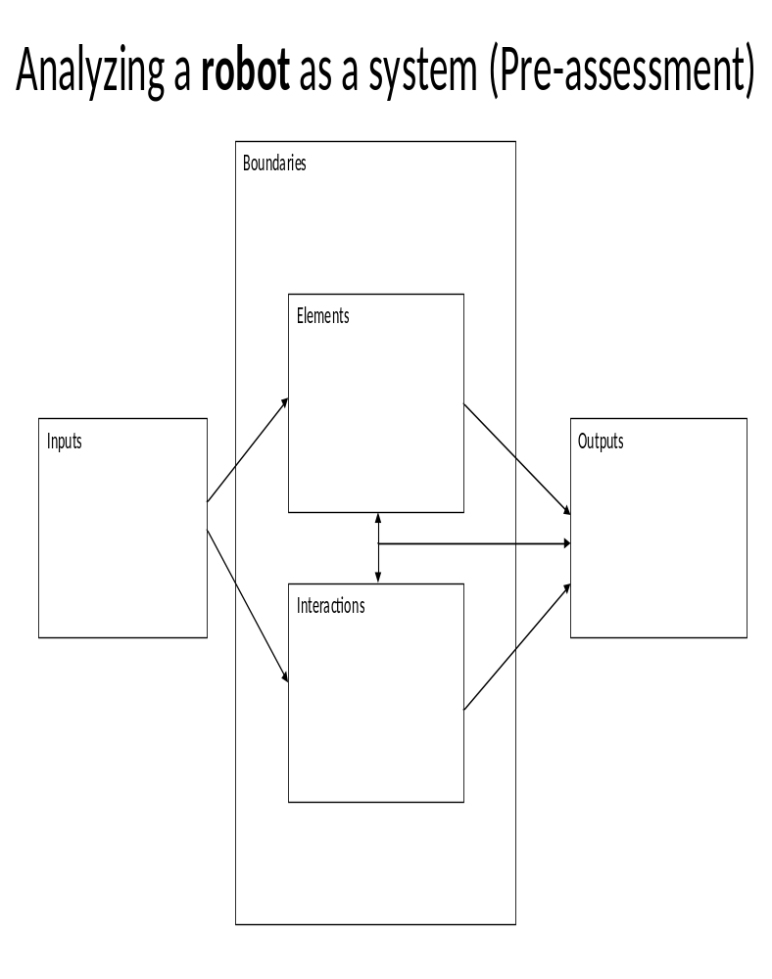
____ Score
Facets of a system:

Element: a distinct part of the system

Boundary: something that indicates or fixes a limit on the size or spread of a system

Interaction: the nature of connections made between elements and inputs of a system

Input: something that is put in the system

Output: something that is produced by the system; a product of the interactions

Teacher’s hints:

Teacher’s hints for understanding a robot as a system (this is not an answer key as answers may vary):

Inputs could include electricity, computer program, design

Boundaries could include metal or plastic, the range of the robot, the computer program, the sensor and motor capabilities

Elements could include batteries, wires, LEGO bricks, motors, sensors, computer processor, memory, attachments

Interactions could include sensing, reading the computer program, moving,

Outputs could include work, movement, sound

Scoring the Systems assessments:

Give students 1 point for every response that fits in the category in which the student wrote it.

Give students ½ point for every response that you are unsure if it fits in the category in which it is placed (however, some items may fit well in multiple categories and should be scored as multiple correct responses). Note that some items may belong in more than one category (e.g., software may be an input, a boundary, an element, and something the robot interacts with).

Give students no point for any response that does not fit in the category in which the student wrote it.

Total the points for each student, writing their score in the correct location. There is no maximum possible score (no ceiling).

Once complete, the pre- and post-assessments can be compared to show student growth.
Name: __________________
Pre-assessment: The Technology Design Loop
Step 5:
Step 2:
Step 1:
Step 4:
Step 3:

What steps should you use to design a robot to complete a challenge?
___ Score

Adapted from the Children’s Engineering Educator’s (2010) Technology Design Loop
Scoring the Technology Design Loop Assessments

Give students 1 point for each response with a similar meaning to the correct step in the Technology Design Loop. Score based on students’ meaning, not exact wording.

Give students ½ point for each answer that is a correct step in the process, but in the wrong sequence or of which you are unsure of if the meaning matches the Technology Design Loop. The latter option should be used only rarely, in cases of teacher uncertainty. It is best to clarify meaning verbally with the student in such cases.

Give no points for blanks or for answers for which the meaning does not match the Technology Design Loop.

Note: As the class is aimed at a variety of learners, pre-writing students may draw their answers to this assessment and then tell you what their drawings mean afterward for scoring purposes. In fact, there is some suggestion that spatially gifted students may be more likely to suffer from reading disabilities than students with similar gifts in math and verbal domains (Mann, 2006).

Total the points for each student, writing their score in the correct location. There is a maximum possible score of 5 for this assessment. This is an achievable score by almost all students. It is the open-endedness of usage possibilities that makes the Technology Design Loop suitable for all learners, including the gifted.

Once complete, the pre- and post-assessments can be compared to show student growth.

A properly organized WeDo kit
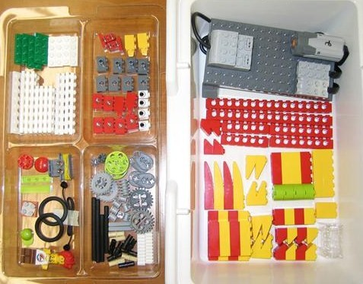
Name: ____________________
Frayer Vocabulary Model
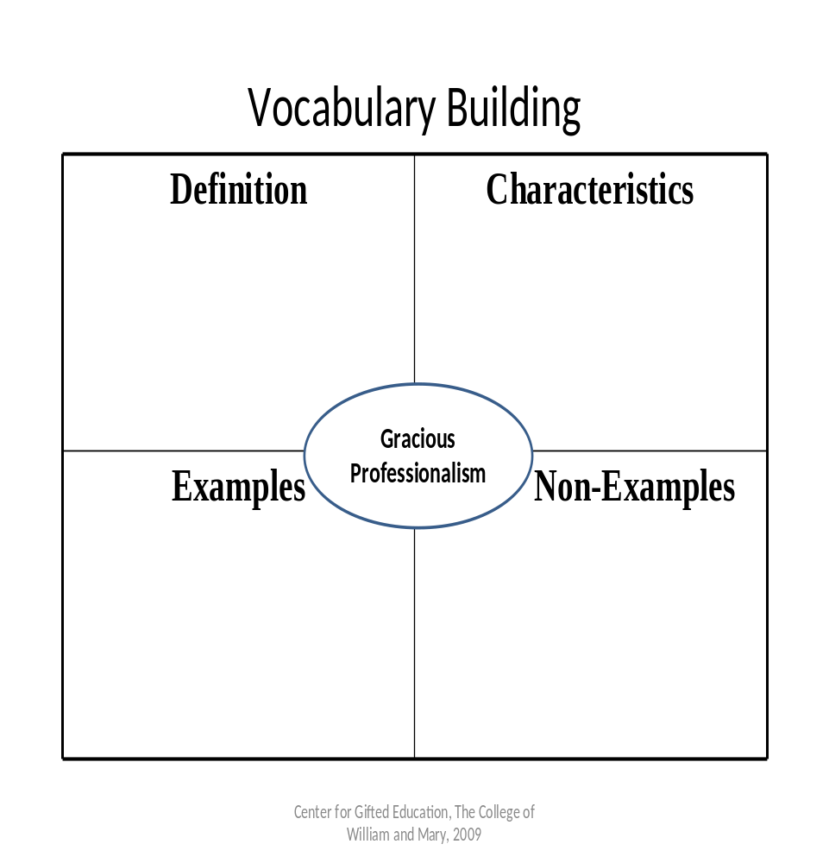
Name: _____________________
Pre-assessment: Robot design
Categories↓ | Needs Improvement  1 | Fair  (Novice)  2 | Good  3 | Excellent  4
Innovative Design  (program and structure in unison) | Design is substandard; not able to achieve the challenge; motor movement is inaccurate; misuse of sensors | Design is standard with no surprises or innovation; achieves the challenge at least some of the time; standard use of sensors | Some unique features that make the design better than average; achieves the challenge all or almost all of the time; thoughtful use of sensors | The design is surprisingly unique, making it superior to others; achieves the challenge every time; superior use of sensors
Structure | Structure is fragile, falling apart under normal use | Structure often holds together under normal use, but is cumbersome or inefficient | Structure is strong and efficient; almost always holds together under normal use | Structure is both solid and elegant; holds up against mishandling
Program | Program unable to complete the challenge; not linked to sensors; illogical | Program often completes the challenge, but inconsistently, inaccurately, or taking more time than needed | Program is logical and efficient; achieves the challenge all or almost all of the time | Program is surprisingly sophisticated; achieves the challenge all of the time

Score: ___

Adapted from the FIRST LEGO League Judges’ Handbook Robot Design rubric
Scoring the Robot Design Rubric

Circle one box per category. When in doubt, score the lower point value. Fours should be avoided except in exceptional cases.

Sum the three scores. The maximum is 12 points, but this score will almost never be achieved. There is almost always room for growth.

Once complete, the pre- and post-assessments can be compared to show student growth.

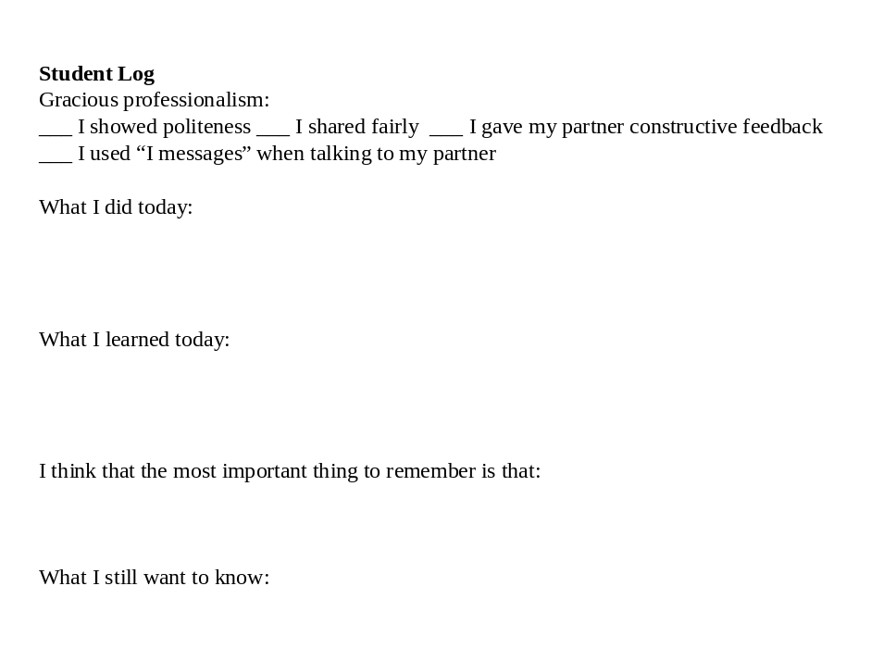
Lesson 2

Purpose: To introduce the systems concept, to introduce the Technology Design Loop, to begin Challenge 2: Lift

Alignment to outcomes: 1, 2a, 3a

Materials: LEGO WeDo set and computer with LEGO WeDo software per pair, one copy of the system’s model per student, student log

Activities:
1) Tell students that many things can be seen as systems: There are economic systems, solar systems, ecosystems. A classroom can be seen as a system as can a family. Today students will explore a very different system than a robot, but one that can be understood through the same model to facilitate learning: an aquarium. Have students draw a large rectangle on the back of their systems model. This is to be the aquarium glass. Introduce the systems concept to students, explaining each of terms. Tell them that they have just drawn a boundary for their aquarium system. (Note: other boundaries exist, including the water, the atmosphere, the electrical system, the size, etc. These can be discussed as appropriate to aid discussion.) Then ask them to brainstorm elements and add them to their aquarium (examples may include fish, plants, rocks, driftwood, decorations, filters, heater, the light fixture, thermometer, crayfish, etc.). Next ask them to brainstorm and draw inputs needed to keep the aquarium system functional (examples may include light for the plants, food for the fish, new medium for the filters, new water to top off for evaporation, etc.). Next ask students to consider what interactions are occurring in the aquarium (examples may include growing, eating, fighting, the nutrient cycle, mating, etc.). They may choose whether to draw one or more of these or to write them down. Finally, students should brainstorm and draw outputs from the system (examples may include dirty water, evaporating water, algae, filter medium, baby fish, deceased [or “sleeping”] fish, etc.).

2) Have students complete the systems model for their aquarium. Lead discussion, reminders, and further brainstorming as necessary.

3) Give students a copy of the Technology Design Loop. Discuss the 5 steps and how they apply to robot design to solve challenges. You may wish to discuss Challenge 2: Lift at this point to allow students to make direct connections to their efforts.

1. What is the problem? This is an important point for students to clarify the challenge with the teacher.
2. Brainstorm solutions. With LEGO, there are nearly infinite possibilities for design. Many different possibilities may exist for success, waiting to be innovated, and some have better chances for success than others.
3. Create the solution you think is best. Starting with a sketch or sketches is highly recommended. This is a challenging, but important step for students to demonstrate gracious professionalism with their partner.
4. Test your solution. The first attempt rarely works perfectly. Designs can nearly always be improved. Student should prepare for multiple unsuccessful or only partly successful attempts and redesigns.
5. Evaluate your solution. Each robot should be tested against the requirements of the challenge. Students should step back to step one to consider even minor problems, even if it only affects part of their robot or program, then move back through the steps to test and evaluate their redesign.

4) Introduce Challenge 2: Lift and assist students only as needed in solving the problem, using inquiry to help lead students solve the challenge themselves. Let students know that this is likely more challenging than yesterday’s challenge and that they will have more time in the next class to work on this challenge.

Challenge 2: Lift: Make a lifter that can move a ball from within 1 inch of the table to 8 or more inches in the air (without letting go of the ball).

5) Have students organize and turn in their kits about 15 minutes before the end of the day. Have them fill out the day’s student log.

Assessment: Students can be observed informally for their use of the Technology Design Loop, gracious professionalism, and robot design. Teachers may wish to make notes from these observations on student strengths and weaknesses to guide the lesson tomorrow. Teachers are also encouraged to read and consider student responses to the student log.

Extension: Make a launcher that launches the ball at least 8 inches into the air and/or 12 inches across the table.

Analyze an aquarium as a system

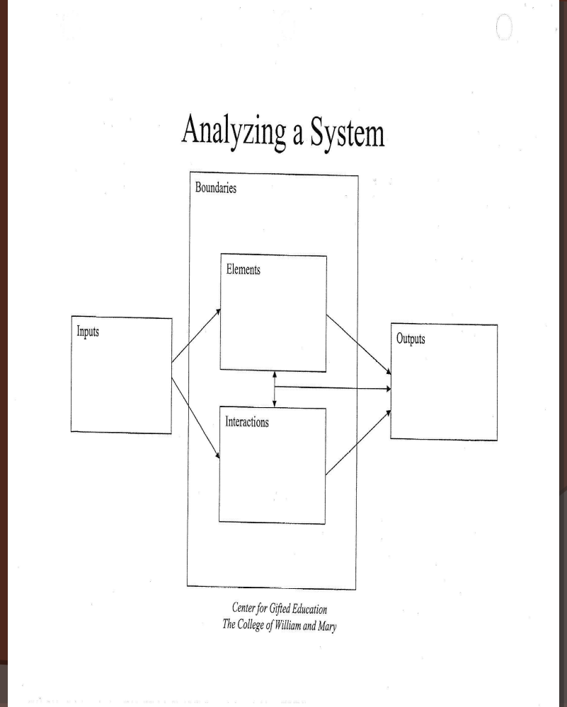

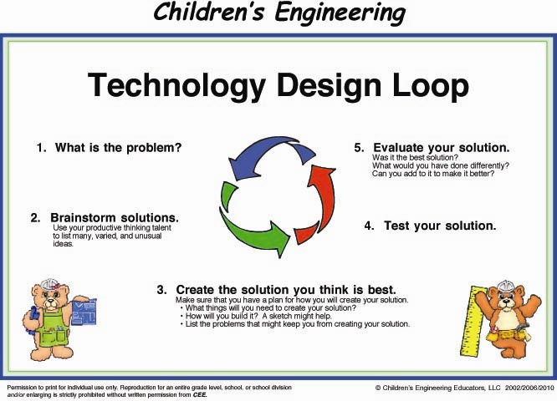

Lesson 3: Review the Technology Design Loop and gracious professionalism, Apply the systems concept, Complete Challenge 2: Lift

Purpose: To review the Technology Design Loop, to review gracious professionalism, to apply the systems concept to computers, to complete Challenge 2: Lift

Alignment to outcomes: 1, 2a, 2/3b, 3a, 4abcd

Materials: LEGO WeDo set and computer with LEGO WeDo software per pair, one copy of the system’s model per student, student log

Activities:
1) Have students access their copies of the Technology Design Loop. Ask them to describe how they used the process in their challenge so far. Ask students to describe how they used gracious professionalism during their work yesterday and, possibly, how they might improve today.

2) Tell students that today they are going to apply the systems concept to computers, a closely related subject to robotics. Teachers may wish to have students draw a computer and label the parts according to the systems model, or, if students seem to be advancing readily without this scaffold, they may proceed directly to brainstorming together to complete the systems model as a class, in small groups, or individually at the teacher’s discretion.

Suggested responses to the model for boundaries include the physical plastic casing of the computer, the network or the Internet, electricity, user competence, the software it has, etc. For elements, students may consider the mouse, keyboard, monitor, wires, hard drive, disk drives, printer, software, etc. For inputs, students may consider data, software, e-mail, webpages, scanned or digital images, CD-ROMs and DVDs, USB drives, etc. Interactions may include programming, typing, critical thinking, researching, gaming, completing homework, etc. Outputs may include software (such as programs written for a LEGO robot), research papers, sounds, print outs, e-mail, videos, etc.

3) Continue with the previous challenge, Challenge 2: Lift or the extension. Both may be found in lesson 2.

4) Have students organize and turn in their kits about 15 minutes before the end of the day. Have them fill out the day’s student log.

Assessment: If desired, teachers may use the robot design rubric to assess students’ final products. Again, students can be observed informally for their use of the Technology Design Loop, gracious professionalism, and robot design. Teachers may wish to make notes from these observations on student strengths and weaknesses to guide the lesson tomorrow. Teachers are also encouraged to read and consider student responses to the student log.

Extension: If students have completed both Challenge 2 and its extension, It is recommended that students spend time with Scratch’s WeDo page at http://info.scratch.mit.edu/WeDo to begin understanding Scratch for tomorrow.
Name: ___________________
Analyze a computer as a system

Lesson 4: Apply the systems concept, Introduction to Scratch, Begin Challenge 3: Game

Purpose: To apply the systems concept to robots, to introduce Scratch, and to begin Challenge 3: Game

Alignment to outcomes: 1, 2a, 3a

Materials: LEGO WeDo set and computer with LEGO WeDo software and MIT’s Scratch software (available free from http://scratch.mit.edu/) per pair, one copy of the system’s model per student, student log

Activities:
1) If possible, watch several videos featuring robots, such as those available from YouTube.com. Example search terms include, but are not limited to: robot, Roomba, Honda robot, Hexbug, robot dance (which usually feature people, but are quite entertaining), BIGDOG robot, robot fish, robotic submarine, autonomous underwater vehicle, etc.

Please note that teachers are highly encouraged to preview all videos before sharing with children. Also, alternate sources of robotics videos can be found if YouTube.com has been blocked from your school’s network including TeacherTube.com.

2) Use the Frayer model of vocabulary to help students understand robots. In this case, you may wish to start with the definition and then have students brainstorm examples and non-examples, concluding with characteristics. A robot is defined here as “a machine that acts autonomously based on a computer program in which a motor or motors reacts based on input from a sensor or sensors.” As a non-example, it is notable that a remote controlled car is not a robot. It does not act autonomously (which children may understand as “on its own”). Such non-examples are very helpful in building understanding of the term.

3) Complete a systems model for robots as a group. Boundaries may include the body of the robot, the program or programmer, the length of the cable (for WeDo), batteries or other electricity, the depth of the ocean (for robotic submarines), etc. Elements may include LEGO bricks, motors, sensors, gears, cables, etc. Inputs may include programs, design, information from sensors, etc. Interactions may include manipulating, finding trapped people (for rescue robots), repairing things underwater (for robotic submarines), solving challenges, following directions/programs, etc. Outputs may include sound, motion, solved challenges, etc. Review all ideas with the group.

4) Tell students that they will be learning a new programming language today where they can make interactive animations and games. It is recommended that students spend time with Scratch’s WeDo page at http://info.scratch.mit.edu/WeDo. It may be most helpful to begin with the WeDo starter projects.

5) Once students have gone through some of the basics of programming WeDo with Scratch, introduce students to Challenge 3: Game and assist students only as needed in solving the problem, using inquiry to help lead students solve the challenge themselves. Let students know that this is likely more challenging than the previous two challenges and that they will have time in the next class to work more on this challenge.

Challenge 3: Game: Create a game in Scratch that is controlled by a WeDo sensor. The game should have instructions at the beginning and a victory note at the end.

6) Have students organize and turn in their kits about 15 minutes before the end of the day. Have them fill out the day’s student log.

Assessment: Teachers should observe how the class does in completing their systems model. Now is an opportune time to correct any misunderstandings about robots as systems. Students can be observed informally for their use of the Technology Design Loop, gracious professionalism, and robot design. Teachers may wish to make notes from these observations on student strengths and weaknesses to guide the lesson tomorrow. Teachers are also encouraged to read and consider student responses to the student log.

Extension: Create a game in Scratch that is controlled by a WeDo sensor and reacts both with an animation on the screen and with the WeDo motor.

Name: ____________________
Frayer Vocabulary Model
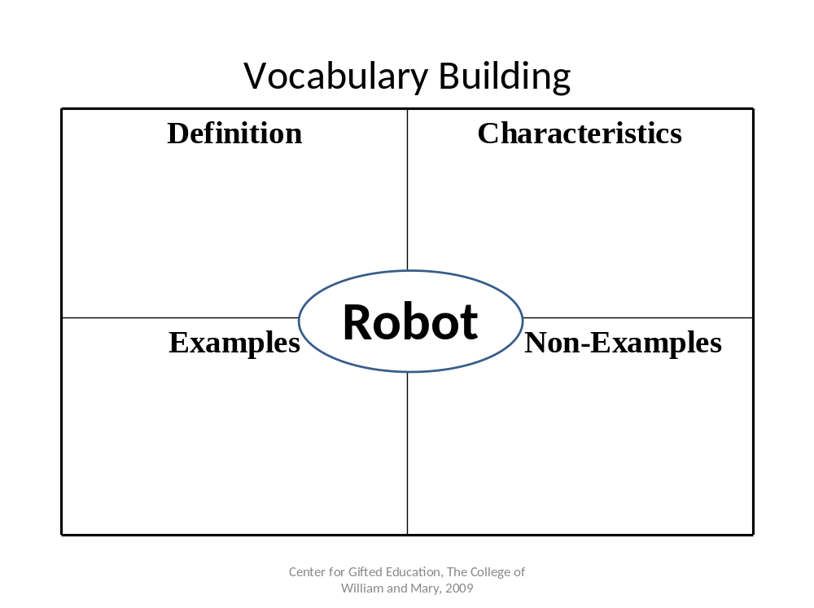

Name: ___________________
Analyze a robot as a system

Lesson 5: Post-assessments, Complete Challenge 3: Game and share

Purpose: To post-assess students for systems, the Technology Design Loop, and robot design; to complete Challenge 3: Game; and to share the final product

Alignment to outcomes: 1, 2a, 2/3b, 3a, 4abcd

Materials: LEGO WeDo set and computer with LEGO WeDo software and MIT’s Scratch software (available free from http://scratch.mit.edu/) per pair, one copy of each of the three pre-assessments per student, student log

Activities:

1) Give the systems post-assessment followed by the design loop post-assessment. Scoring will be the same as with the pre-assessments and directions for scoring all assessments have been provided in lesson 1.

2) Allow students the majority of the period to continue Challenge 3: Game. Students who finish that are encouraged to share their game with others, including online via the Scratch website and to continue on with the extension.

Challenge: Continued from lesson 4.

3) Teachers may wish to arrange a time for families to visit on the last day so that students can share their creations.

4) Have students organize and turn in their kits about 15 minutes before the end of the day. Have them fill out the day’s student log.

Assessment: As students complete Challenge 3: Game, teachers should complete the robot design post-assessment rubric. Pre- and post-assessments can now be compared to look at student growth and teachers can provide this information for students and their families. Teachers are encouraged to make notes on overall student strengths and weaknesses in order to improve instruction for future classes.

Extension: Continued from lesson 4 and widely extendable. Students who are able to complete both in the given time frame may be interested in exploring other features of Scratch such as the 1.1 million submissions of games and animations that have been submitted to date. Likely, students will become interested in creating another game in Scratch, with or without WeDo or to create and program a new robot with or without Scratch. The possibilities are endless.

Name: ___________________
Post-assessment: Analyze a robot as a system

___ Score

Name: __________________
Post-assessment: The Technology Design Loop
Step 5:
Step 2:
Step 1:
Step 4:
Step 3:

What steps should you use to design a robot to complete a challenge?
___ Score

Adapted from the Children’s Engineering Educator’s (2010) Technology Design Loop
Post-assessment: Robot design
 | Needs Improvement  1 | Fair  (Novice)  2 | Good  3 | Excellent  4
Innovative Design  (program and structure in unison) | Design is substandard; not able to achieve the challenge; motor movement is inaccurate; misuse of sensors | Design is standard with no surprises or innovation; achieves the challenge at least some of the time; standard use of sensors | Some unique features that make the design better than average; achieves the challenge all or almost all of the time; thoughtful use of sensors | The design is surprisingly unique, making it superior to others; achieves the challenge every time; superior use of sensors
Structure | Structure is fragile, falling apart under normal use | Structure often holds together under normal use, but is cumbersome or inefficient | Structure is strong and efficient; almost always holds together under normal use | Structure is both solid and elegant; holds up against mishandling
Program | Program unable to complete the challenge; not linked to sensors; illogical | Program often completes the challenge, but inconsistently, inaccurately, or taking more time than needed | Program is logical and efficient; achieves the challenge all or almost all of the time | Program is surprisingly sophisticated; achieves the challenge all of the time

Score: ___

Adapted from the FIRST LEGO League Judges’ Handbook Robot Design rubric
Robotics in the K-12 Classroom: A Brief Literature Review
Introduction
Robot is a term first coined in 1920 by Czech playwright Karel Capek from the Czech word for forced labor, robota (James & Leon, n.d.). Although once only a playwright’s fancy, today robots labor around the world and beyond, and they are playing increasingly important roles in society. From autonomous submarines working to stop the BP oil pipe disaster in water too deep for humans to travel (BBC News, 2010), to robotic prosthetics (Fischman, 2010), and for space exploration (James & Leon, n.d.), robots advance the human condition.
The fields of science, technology, engineering, and math (STEM) account for the majority of America’s economic growth and tremendous improvement of the human condition (National Academy of Sciences, 2005). Among these are innovations in robotics. In the U.S., however, too few college students are majoring in STEM fields to fill demand in the job market (American Competitiveness Initiative, 2006). A key ingredient in this may be a lack of emphasis for science education at the elementary level (National Research Council, 2007). As the typical elementary school divides its days among the core subjects of language arts, social studies, math, and science, robotics could be most appropriately studied during math or science time. However, spatial reasoning, which is so important to success in STEM fields and used in engineering robotics, is an ability distinctly separate from math ability (Wai, Lubinski, & Benbow, 2009). Science is therefore likely the best subject in which schools could situate robotics. Also, the most widespread robotics competitions for children, the FIRST programs, revolve around a specific real-world science theme each year (Coxon, 2010).
While many options exist for learning with robotics at young ages, few schools provide their students with such possibilities until secondary school, if at all. At such a late point, many students with the potential to be STEM innovators have likely found other passions more in line with school’s verbal focus (Wai, Lubinski, and Benbow, 2009). This is potentially limiting for students. The science literature suggests that students do not tend to make up for such lost learning. For example, Novak’s (2005) longitudinal work on science learning over the course of 30 years has demonstrated that students who receive science education starting in second grade continue to have greater conceptual understanding than those who do not receive science education until sixth grade throughout their senior years of high school. While science instruction typically starts earlier now, it is still largely of poor quality at the elementary level (NRC, 2007). This missed learning is likely limiting the number of students going into STEM majors in college.
As a part of improving science education and more future STEM majors, robotics learning should be available to elementary students. Problem-based learning, such as can be conducted with robotics, is engaging for children (Allen, 1996). Such engagement in science learning through real-world problem-solving potentially leads to college majors in STEM fields (Wai, Lubinski, & Benbow, 2009). Likewise, numerous robotics programs and academic competitions, such as the For Inspiration and Recognition in Science and Technology (FIRST) LEGO League (FLL), make for ready robotics interaction in schools and other educational settings. Meta-analysis has revealed that, with an effect size of 1.48, enhanced context strategies have the highest effect size on achievement of all researched forms of science education (Schroeder, Scott, Tolson, Huang, & Lee, 2007). According to Schroeder et al. (2007), enhanced context strategies include real-world learning and problem-based learning. Robotics is especially appropriate for aiding with both of these enhanced contexts in the classroom. The same meta-analysis found that instructional technology use has an overall effect size of .48 on science achievement. Robotics falls into this category as well. While a smaller effect size, it is still a powerful one. Some research already exists specifically on the effects of robotics use in classrooms, which will be explored here.
Robotics Education
The launch of Sputnik had such a large impact on American STEM education (Flanagan, 1979; Super & Bachrach, 1957; Wai, Lubinski, & Benbow, 2009) that it could arguably be considered the impetus for robotics education in the U.S., despite the fact that the first programmable robot had only just been developed (Robots.com, n.d.). Robotics use in the classroom was not immediate, but began sooner than many people might guess. While robots were just becoming common to industry in the 1970s (Robots.com, n.d.), LEGO Logo, which connects LEGO bricks and motors to the popular programming language, was introduced for children in the early-1980s (Fox, 2007; Logo Foundation, 2000). Still, there is not evidence that the use of robotics in schools was widespread until the advent of LEGO Mindstorms and the corresponding FLL competition in the late 1990s. Today, many kits exist for engaging students in robotics including with the popular building toy, K’nex, LEGO WeDo, LEGO NXT, the T-Bot mechanical arm, and Tetrix, which allows students to build sturdy robots with aircraft-grade aluminum. Curriculum units are available for several of the kits both from some of the companies that produce the kits and from third parties (e.g., Coxon, 2010; Toye & Williams, n.d.). There are also several dozen robotics competitions available to students K-12 at international, national, and regional levels including FIRST Robotics Competition (FRC), Junior FLL, FLL, Fire Fighting Robot Contest, VEX Robotics, and Carnegie Mellon Mobot Races (Coxon, 2009; Robots.net; Tallent-Runnels & Candler-Lotven, 2008). Of particular importance for elementary age children are the Junior FLL for ages 6-9 utilizing the LEGO WeDo kit and FLL for ages 9-14 utilizing the NXT kit. Both are academic competitions in which students build robots to manipulate LEGO objects built based on a real-world science theme. For example, in a recent FLL competition, Power Puzzle, the theme was energy production and use. Participants were required to build and program a robot that could add a solar panel to a house and replace a pick-up truck in its driveway with a fuel cell car—all made from LEGO bricks. The competitions have multiple facets. Not only do robots compete, but participants also compete for awards in teamwork, robot design, and a presentation on a public service research project that they conduct before the competition. These competitions are widely available. FIRST programs have a total reach of more than 212,000 K-12 students in about 60 countries (US FIRST, 2010). As is common to educational technology, the research on participant outcomes lags behind usage.
The use of robots in education has rarely been researched in K-12 classrooms. A search on ERIC using the keyword “robot” revealed 187 articles, only 62 of which were published since 2000, which this review will be limited due to the rapidly changing nature of technology. Further discounting many that were not research studies, the majority of those remaining either report on studies of post-secondary programs (e.g., Wallace, McCartney, & Russell, 2010), studies of assistive technology (e.g., Krebs, Landenheim, Hippolyte, Monterroso, & Mast, 2009), studies that use robotics to study child behavior (e.g., Moriguchi, Kanda, Ishiguro, & Itakura, 2010), and studies in which robots are used to study cognition (e.g., Shimada, 2010). In total, only nine studies were identified for this review.
Of the K-12 studies available, the largest number involve the FIRST competitions, the largest and most widely distributed robotics programs, followed by those that use the same LEGO robotics sets in the classroom. Perhaps the largest scale research to date was conducted with participants involved in the FRC, a high school level competition, by the Center for Youth and Communities (CYC) at Brandeis University. Melchior, Cohen, Cutter, and Leavitt (2005) conducted a survey, finding that, in comparison to their peers, FRC participants were 35% more likely to attend college, twice as likely to major in a STEM field, nine times as likely to have an internship during their college freshman year, and even twice as likely to perform community service. Of course, it is unclear if those differences were created by FRC participation or if they are simply indicative of students interested in such competitions. In a similar study from CYC of the FLL, Melchior, Cutter, and Cohen (2004) conducted a survey of FLL participants, coaches, and parents. Of those surveyed, 94% or more believed that FLL participants had increases in such areas as programming skills, understanding of how science and technology can solve real world problems, problem-solving skills, and leadership skills. Definitive pre- and post-assessment studies are still lacking.
Some studies of FLL suggest that student learning in robotics competitions may generalize to other contexts. In a qualitative study, Petre and Price (2004) observed several robotics competitions in the Seattle area, including FLL, and interviewed participants and coaches. Key themes that emerged included students’ desires to complete the tasks, the open-endedness of competition, and the social context. Based on these interviews, the researchers suggest that robotics works effectively to increase understanding of programming and engineering principles, and that this learning was generalizeable to other programming and engineering situations. Geeter, Golder, and Nordin (2002) were attempting to increase the number of FLL teams in Iowa through a university-based program. Based on their observations during this time, they reported that middle school students competing in FLL gained a better understanding of engineering; improved creative thinking, critical thinking, and problem-solving skills; and increased self-confidence levels, interest, and involvement in science and math. They suggest that these skills will help students regardless of the career path that they choose, but do not report on their methods for making these assertions aside from observation during their program.
Robotics has been less well studied in the classroom. The studies that do exist continue to explore robotics education through qualitative means. Korchnov and Verner (2010) conducted a qualitative study of student teachers and their pupils involved in a robotics curriculum. They found that self-confidence, learning effort, and coping with learning pressures improved along other variables. Verner and Hershko (2003) followed students through a robotics curriculum and found that they were motivated to complete their projects. Robotics has also been studied in a remedial classroom. A thesis study which included a Likert survey found that a LEGO robotics curriculum helped students ages 11 and 12 in a remedial group to better understand their learning styles and to improve in their problem-solving skills (Swartz, 2007).
An even smaller amount of research has been quantitative. Williams, Ma, Prejean, Ford, and Lai (2007) found that middle school students using LEGO RCX (the predecessor to the NXT) in the classroom improved in physics content knowledge using a pre- and post-assessment. The researchers also looked for student gains in scientific inquiry skills but did not find significant changes. Their study suffered from attrition and a small sample. Verner (2004) conducted one of the most rigorous studies using Robocell, a robotic arm that can move through five joints. He looked specifically at middle and high school students’ (n=128) gains in spatial abilities on 12 spatial tasks. Over the course of treatment with Robocell curriculum, students improved from an average of 46.5% correct on the pre-assessment to 62.4%. This study is especially important both because its large sample and number of assessments may make it more convincing for those making financial and policy decisions in schools, such as for the inclusion of robotics programs, as well as because spatial abilities and future success in STEM fields are strongly correlated (Wai, Lubinski, & Benbow, 2009). More studies such as this are sorely needed.
Conclusion
Robotics education has expanded to hundreds of thousands of K-12 students, but little research has been thus far conducted that demonstrates the benefits of such involvement through pre- and post-gains on reliable instruments. However, the benefits, such as increased interest and ability in STEM fields, are potentially great and the little existing research does suggest that those benefits are attainable. More research is demanded from a society that increasingly benefits from and even depends upon STEM innovations, such as those in robotics. Research showing post-assessment gains in needed faculties such as spatial ability may be most helpful in convincing policy makers to include robotics programs in school budgets and curriculum.

References
Allen, D. E. (1996). The power of problem-based learning in teaching introductory science courses. New Directions for Teaching and Learning, 68, 43-52.
American Competitiveness Initiative. (2006). American competitive initiative: Leading the world in innovation. Washington DC: Domestic Policy Council Office of Science and Technology. Retrieved from http://www.innovationtaskforce.org/docs/ACI%20booklet.pdf
BBC News. (2010, April 26). Oil rig spill off Louisiana could threaten coastline. BBC News. Retrieved from http://news.bbc.co.uk/2/hi/americas/8642518.stm
Coxon, S. V. (2009). Challenging neglected spatially gifted students with FIRST LEGO League. Addendum to Leading Change in Gifted Education. Williamsburg, VA: Center for Gifted Education. Retrieved from http://cfge.wm.edu/Documents/Festschrift Supplement.pdf#page=25
Coxon, S. V. (2010). STEMbotics. Steve Coxon’s Web: Presentations. Retrieved from http://stevecoxon.com/
Fischman, J. (2010, January). A better life with bionics. National Geographic, 217(1), 34-53.
Flanagan, J. C. (1979). Findings from Project TALENT. Educational Forum, 43(4), 489-90.
Fox, H. W. (2007). Using robotics in the engineering technology classroom. The Technology Interface. Retrieved from http://technologyinterface.nmsu.edu/Spring07/18_Fox/index.pdf
Geeter, D. D., Golder, J. E., & Nordin, T. A. (2002). Creating engineers for the future. Proceedings of the 2002 American Society for Engineering Education Annual Conference & Exposition, 1-7.
James, D., & Leon, M. (n.d.). Liftoff to learning: Let’s talk robotics. NASA Quest. Retrieved from http://quest.nasa.gov/space/teachers/liftoff/robotics.html
Korchnov, E., & Verner, I. M. (2010). Characteristics of learning computer-controlled mechanisms by teachers and students in a common laboratory environment. International Journal of Technology and Design Education, 20(2), 217-237.
Krebs, H. I., Landenheim, B., Hippolyte, C., Monterroso, L., & Mast, J. (2009). Robot-assisted task-specific training in cerebral palsy. Developmental Medicine & Child Neurology, 51(4), 140-145.
LOGO Foundation. (2000). What is LOGO? Retrieved from http://el.media.mit.edu/Logo-foundation/logo/index.html
Melchior, A., Cohen, F., Cutter, T., & Leavitt, T. (2005). More than robots: An Evaluation of the FIRST Robotics Competition participant and institutional impacts. Waltham, MA: Center for Youth and Communities, Brandeis University. Retrieved from http://www.usfirst.org/who/content.aspx?id=46
Melchior, A., Cutter, T., & Cohen, F. (2004). Evaluation of FIRST LEGO League. Waltham, MA: Center for Youth and Communities, Brandeis University. Retrieved from http://www.usfirst.org/who/content.aspx?id=46
Moriguchi, Y., Kanda, T., Ishiguro, H., & Itakura, S. (2010). Children perseverate to a human's actions but not to a robot's actions. Developmental Science,13(1), 62-68.
National Academy of Sciences. (2005). Rising above the gathering storm. Washington, DC: National Academy Press. Retrieved from http://www.nap.edu/catalog.php?record_id=11463
National Research Council. (2007). Taking Science to School: Learning and Teaching Science in Grades K-8. Committee on Science Learning, Kindergarten Through Eighth Grade. R. A. Duschl, H. A. Schweingruber, and A. W. Shouse, (Eds.). Board on Science Education, Center for Education. Division of Behavioral and Social Sciences and Education. Washington, DC: The National Academies Press.
Novak, J. D. (2005). Results and implications of a 12-year longitudinal study of science concept learning. Research in Science Education, 35(1), 23-40.
Petre, M., & Price, B. (2004). Using robotics to motivate ‘back door’ learning. Education and Information Technologies, 9(2), 147-158.
Robots.com. (n.d.). Industrial robot history. Robots.com. Retrieved from http://www.robots.com/robot-education.php?page=industrial+history
Robots.net. (n.d.). Robot competitions. Robots.net. Retrieved from http://robots.net/rcfaq.html
Schroeder, C. M., Scott, T. P., Tolson, H., Huang, T. –Y., & Lee, Y. –H. (2007). A meta-analysis of national research: Effects of teaching strategies on student achievement in science in the United States. Journal of Research in Science Teaching, 44(10), 1436-1460.
Super, D. E., & Bachrach, P. B. (1957). Scientific careers and vocational development theory. New York: Bureau of Publications, Teachers College, Columbia University.
Swartz, T. J. (2007). Integrating LEGO Mindstorms Robotics into the classroom. Unpublished master’s thesis, Emporia State University, Emporia, KS.
Wallace, S. A., McCartney, R., & Russell, I. (2010). Games and machine learning: A powerful combination in an artificial intelligence course. Computer Science Education, 20(1), 17-36.
Tallent-Runnels, M. K., & Candler-Lotven, A. C. (2008). Academic competitions for gifted students: A resource book for teachers and parents (2nd ed.). Thousand Oaks, CA: Corwin.
Toye, A., & Williams, B. (n.d.). Robotics in the classroom: Introduction to Robiotics. Wright, OH: Wright-Patterson Air Force Base Educational Outreach Office. Retrieved from http://edoutreach.wpafb.af.mil/Robotics/media/resources/intro_robotics_5th.pdf
US FIRST. (2010). FIRST At-A-Glance. Retrieved from http://www.usfirst.org/who/content.aspx?id=160
Verner, I. M., & Hershko, E. (2003). School graduation project in robot design: A case study of team learning experiences and outcomes. Journal of Technology Education, 14(2), 40-55.
Verner, I. M. (2004). Robot manipulations: A synergy of visualization, computation and action for spatial instruction. International Journal of Computers for Mathematical Learning, 9, 213-234.
Wai, J., Lubinski, D., & Benbow, C. P. (2009). Spatial ability for STEM Domains: Aligning over 50 years of cumulative psychological knowledge solidifies its importance. Journal of Educational Psychology, 101(4), 817-835.
Williams, D. C., Ma, Y., Prejean, L., Ford, M. J., & Lai, G. (2007). Acquisition of physics content knowledge and scientific inquiry skills in a robotics summer camp. Journal of Research on Technology in Education, 40(2), 201-216.

Online Resources
The LEGO WeDo software comes with tutorials for the basics of WeDo building and programming and the novice will be best served by starting there. Separate introductory curriculum can be purchased through the LEGO WeDo website. As of this writing, there are no other third party books or curriculum units available to the author’s knowledge. However, a great deal of information is available online:

LEGO Education homepage:
http://www.lego.com/education/default.asp

For Inspiration and Recognition of Science and Technology (FIRST) competitions, including the Junior FIRST LEGO League that utilizes LEGO WeDo (search for available workshops in your area):
http://www.usfirst.org/

Scratch download and sharing (excellent tutorials available):
http://scratch.mit.edu/

Scratch’s WeDo page:
http://info.scratch.mit.edu/WeDo

Children’s Engineering Educators (search for available workshops in your area):
http://www.childrensengineering.com/

Instructables, an online “how to” forum that includes many WeDo ideas*:
http://www.instructables.com/

An introduction to WeDo video by LEGO:
http://cache.lego.com/downloads/education/LEGO_WeDo_5MB.mov

An introduction to WeDo video by the author**:
http://www.youtube.com/watch?v=hd2I9W86olM

*Some features of this website are only available for a small fee.

**Many more educational videos on Scratch and WeDo are available by searching those terms on youtube.com. Educators are encouraged to preview all videos to be used with children for quality and suitability.

