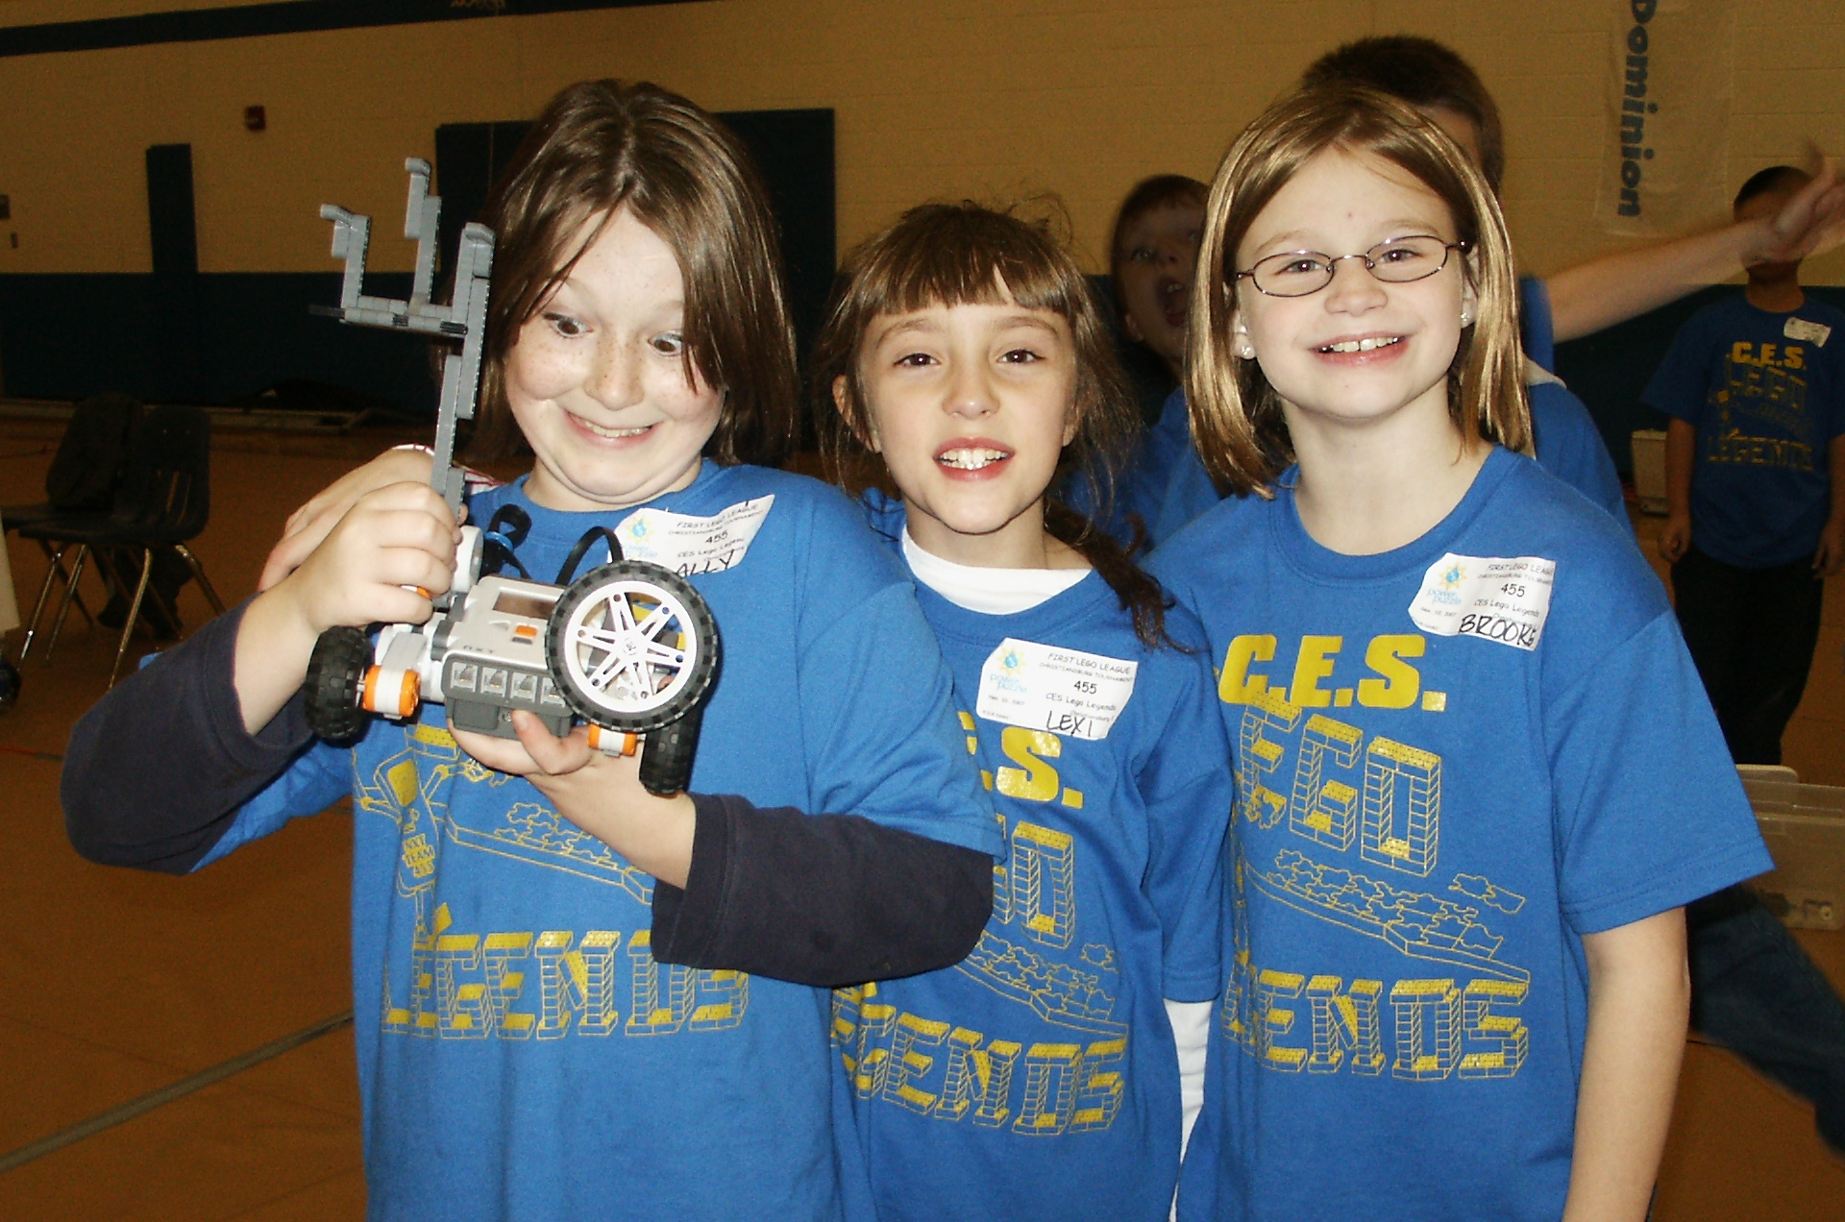
STEMbotics

Using Edward de Bono’s Six Thinking Hats and LEGO NXT Robotics to understand STEM systems:
A problem-solving unit for
Grades 4-9

by Steve Coxon
Table of Contents
Curriculum unit description 3
Nature of differentiation for gifted learners 4
Content outline 5
Prerequisite skills and concepts 6
Goals and outcomes 7
Major instructional strategies 8
Challenge 1: Agricultural scientist (Pre-assessment) 9-10
Challenge 2: Architect 11-12
Using de Bono’s Six Thinking Hats 13
Challenge 3: Storm water manager/Using the rotation sensor 14-15
Systems in science, technology, engineering, and math 16
Challenge 4: Structural engineer/Engineering fundamental: The drop test 17-18
The drop test 19
Challenge 5: Educator/Using the touch sensor 20-21
Challenge 6: Designer/Attaching a drawing implement 22-23
Challenge 7: Geoscientists/Using the ultrasonic sensor 24-25
Challenge 8: Video game creator/Engineering fundamental: Gear ratios for speed and torque 26-27
Challenge 9: Electrician/Using the light sensor 28-29
Challenge 10: Surgeon (Post-assessment) 30-31
Additional challenges (Past FIRST LEGO League mats) 32
Assessment procedures 33
STEM questionnaire pre- and post-assessment 34
Scoring the STEM questionnaire 35
Analyzing a System graphic organizers:
Analyzing a System Pre-assessment: Computers as systems 36
Analyzing a System Pre-assessment: Sample for computers as systems and scoring 37
Analyzing a System: Storm water as a system (with challenge 3) 38
Analyzing a System: Storm water as a system (unnumbered sample)
Analyzing a System: The Earth as a system (with challenge 7) 39
Analyzing a System: Post-assessment: The human body as a system (use with challenge 10) 40
Robot design rubric 41
Scoring the Robot design rubric 42
de Bono’s Six Thinking Hats pre-assessment 43
de Bono’s Six Thinking Hats post-assessment 44
Scoring the Six Thinking Hats assessments 45
Resources 46-47
Glossary 48

Curriculum unit description
STEMbotics is a problem-solving unit. Students will learn to use de Bono’s Six Thinking Hats method and LEGO NXT robotics to overcome challenges in a variety of STEM disciplines. Students will come to understand aspects of STEM disciplines as systems. There are four main components in this unit:
1) Problem-solving with the Six Thinking Hats method
2) Engineering and programming LEGO NXT robots
3) Learning about careers in STEM disciplines
4) Understanding aspects of STEM disciplines as systems.
1) Problem-solving is the overarching concept of this unit. You’ll notice that the “lessons” are called “challenges” in this unit because, while students will learn many valuable lessons, the focus is on the challenging problems to be overcome. This unit is designed to improve how students go about solving a problem. As such, teachers will spend very little time giving whole class instruction and students will spend the majority of their time hands-on engaged than in a typical classroom. Teaching a specific problem-solving method helps students become more proficient problem-solvers. There are many methods that could be utilized. The Six Thinking Hats method developed by Edward de Bono is one that may be easily learned by elementary and middle school students. The method is detailed in challenge 2.
2) Engineering and programming LEGO NXT robots directly involves students in several STEM disciplines including mechanical engineering and computer programming. In this unit, students will learn two mechanical engineering fundamentals: to build strong designs (challenge 4) and to use gear ratios to manipulate speed and torque (challenge 8). Students will learn several computer programming fundamentals throughout the challenges, including the use of repeat loops and switches.
3) Careers in Science, Technology, Engineering, and Math are in demand. Employers expect to hire 2.5 million STEM workers between 2004 and 2014 (Terrell, 2007). Due in part to this demand, pay is high: On average, STEM workers earned about 70% more than the U. S. average in 2005 (Terrell, 2007). However, students who do not prepare well in high school will have a tougher time getting into and succeeding in STEM college programs. As middle school coursework, particularly in mathematics, often decides where students begin their coursework in high school and therefore what level they complete, career counseling for students with aptitude in STEM subjects should begin in upper elementary and middle school. Students with gifted abilities in mathematical and/or spatial reasoning are particularly likely to excel in STEM careers. Still, many students have a limited view of STEM disciplines and should be made aware of the variety of careers in STEM to have the greatest chance of sparking and maintaining interest. Students will learn about a different STEM discipline in each challenge in this unit.
4) Systems is a concept that reaches across all STEM disciplines. By analyzing this concept in depth on specific aspects of several STEM disciplines, students should not only come to better understand particular systems, but begin generalizing this concept across disciplines. In this unit, students will analyze computers, storm water, the Earth, and the human body as systems.

Reference
Terrell, N. (2007). STEM occupations. Occupational Outlook Quarterly, 51(1), 26-33.
Nature of differentiation for gifted learners
The content and materials are highly accelerated and offer numerous opportunities for creative problem-solving. LEGO NXT robotics was created for academic competition in a partnership between LEGO and For Inspiration and Recognition in Science and Technology (FIRST), a non-profit dedicated to providing academic challenges for students from primary through high school. The FIRST robotics competition was designed to interest high school students in pursuing STEM disciplines in college. Later, the FIRST LEGO League competition was created for middle school students. The materials are now being used for elementary school students, thus they provide a highly accelerated challenge for elementary students. Students must both design and build the robots and then program them to complete challenges (manipulating other LEGO objects representing items in a STEM topic).
In order to facilitate this, students are taught a specific problem solving method. Gifted students are likely to be particularly adept at using a problem solving method. Students who best utilize de Bono’s Six Thinking Hats method to consider all aspects of the challenge they need to complete, will likely design a suitable robot with appropriate features (e.g., a touch sensor on the right side if the robot will need to follow a wall on the right).
The building requires using gears, putting sensors and motors in appropriate places for the challenge, and strength, lest the robot fall apart. All of this requires a quality of design and construction rarely asked of children this age. Likewise, students will be learning the same logic used by adult computer programmers. While NXT-G is easier to use than C++ or Java, it uses the same logic: Repeat loops and switches must be used in order to create programs that can follow a line or find the correct color flag to flip.
All of these aspects—problem-solving, the materials (their design and engineering), and the programming—contain unlimited creative possibilities. There is no one correct answer—there are many ways to solve any problem. Students may choose a light sensor over an ultrasonic sensor in their design or they may choose to solve one problem but not another because of interest or points earned, but each choice contains a high level of challenge. Creativity plays a large role. Students who solve the problems creatively may be able to solve more in a short amount of time and/or solve them more consistently than others, allowing them to earn more points.
Students will be pre-assessed on their knowledge of the Thinking Hats, a STEM questionnaire, the Analyzing a System graphic organizer, their engineering and programming a robot in a preliminary challenge (via the Robot Design rubric), and the actual points they earn based on their robot achieving defined goals in that challenge. The curriculum can be adapted based on the scores, particularly in teaching time spent on Thinking Hats, depth of information for each STEM topic, level of programming taught, and engineering fundamentals taught. Assessment will be conducted all along by each student scoring points within each challenge, as well as occasional use of the Robot Design rubric, Thinking Hats assessment, and the Analyzing a System graphic organizer. Post-assessment will look for improvement in all five areas. All challenges, including the pre-post challenges, will be designed in such a way that it is very easy to earn some points (low floor) and almost impossible to score 100% (high ceiling) so that a true assessment can be made of both neophytes to LEGO robotics as well as those with lots of experience (it’s assumed that the curriculum is only for students with high aptitude).

Content outline
Each challenge will take about four hours, for a total of 40 hours to complete the entire unit. Challenges may be spread into multiple days. For examples, Challenge 1 may be accomplished all in one 8 a.m. to noon morning, spread into two two-hour after school sessions, divided into a standard 45-50 minute class period Monday through Friday, etc. It is not recommended that any challenges be skipped, but if the circumstance demands it, Challenge 6, while the most unique, is the least integral. All other challenges build on one another. Challenges 1 and 10 include the pre- and post-assessments, Challenges 3 and 7 include mid-point assessments of Analyzing a System, Challenge 2 introduces the Six Thinking Hats, Challenges 3, 5, 7, and 9 introduce the sensors in order of difficulty of use, and challenges 4 and 8 introduce important engineering concepts. All challenges include a different STEM career. All challenges may be used as assessments of design, engineering, and programming using the Robot Design rubric and the points earned in solving each challenge aspect.

Challenge 1: Agricultural scientist (Pre-assessment)
Systems in science, technology, engineering, and math
Challenge 2: Architect/Using de Bono’s Six Thinking Hats
de Bono’s Six Thinking Hats
Challenge 3: Storm water manager/Using the rotation sensor
Challenge 4: Structural engineer/Engineering fundamental: The drop test
Challenge 5: Educator/Using the touch sensor
Challenge 6: Designer/Attaching a drawing implement
Challenge 7: Geoscientists/Using the ultrasonic sensor
Challenge 8: Video game creator/Engineering fundamental: Gear ratios for speed and torque
Challenge 9: Electrician/Using the light sensor
Challenge 10: Surgeon (Post-assessment)

Prerequisite skills and concepts
This is not intended to be a unit for novices. Students are expected to begin this unit with a set skills and conceptual understandings. Students should be moderately proficient builders with traditional LEGO bricks. This will allow students a platform from which to move to the next level of building with LEGO Technics bricks, which contain holes for pin connections along with the traditional studs. Students should be familiar with basic computer parts—mouse use and USB ports in particular. A basic knowledge of the programming language, NXT-G, is also highly recommended. Past experience with problem-solving will further ensure student readiness, especially beneficial would be the completion of one or more units in problem-based learning (PBL), such as The College of William and Mary’s Center for Gifted Education’s Electricity City and Acid, Acid Everywhere or experience in academic competitions such as Odyssey of the Mind and FIRST LEGO League. A list of other resources, including curriculum for novices, can be found in the Resources section at the end of this unit.
Still, because of the pre-assessment model, teachers will have the ability to see where student deficiencies exist at the beginning of the unit and modify instruction to differentiate for those students. Please see the Major instructional strategies section for grouping suggestions for these students.

Goals and outcomes
Goals:
1. Students’ designing, programming, and engineering skills will increase.
2. Students’ ability to think about and solve a problem will improve.
3. Students’ knowledge about STEM disciplines will increase.
4. Students’ understanding of the concept of systems will improve.

Outcomes:
1. Students will build strong, capable robots designed and programmed for the task at hand as determined by both the Robot design rubric and the points earned as the challenges progress from Challenge 1 to Challenge 10.
2. Students will use The Six Thinking Hats to discuss and solve problems.
3. Students will improve their responses on a STEM questionnaire between Challenge 1 and Challenge 10.
4. Students will improve their responses on the Analyzing a System graphical organizer between Challenge 1 and Challenge 10.

Major instructional strategies
The teaching approach is one of coaching. In this unit, teachers are requested to act as coaches. That is, they should keep students on task and focused, demonstrate the Thinking Hats approach to problem solving, and ask questions to help students determine possible solutions.
Depending on student proficiency on the pre-assessments, teachers may still need to teach the basics of NXT-G programming language and good LEGO building, but should keep their hands off student work, providing examples, but not solutions to the problem the student faces. For example, the teacher may show students how pins can create a stronger bond than simply snapping the blocks together, but should refrain from telling students how to make an arm attach more strongly to their robot. This method ensures that students are becoming problem solvers themselves.
Students may proceed independently or in small groups, depending on student and teacher preference, other classroom goals such as teamwork, and the available resources (one computer and one NXT kit are needed per group). When grouping students, two things are particularly important for the teacher to consider: Groups larger than three make it nearly impossible for all group members to be on-task at a given time and groups should consist of students of similar achievement in the pre-assessments. Pairing strong pre-achievers with weaker pre-achievers is unfair to all. Students who do well on the pre-assessment should not be asked to use a large portion of their time teaching others the basics. They should improve their skills and understandings in this unit as well. While all students may have unique skill sets and ideas that they sometimes share, placing a strong student with weaker students asks that student to do two jobs: the teacher’s and the weaker pre-achievers’. Weaker pre-achievers may fail to make their maximum gains, particularly in problem-solving, when they are paired with stronger pre-achievers because they may come to rely on the stronger pre-achiever and fail to realize their own potential. This unit’s pre- and post-assessment model does not have one minimum standard as its goal, but improvement for all students to their potential.
Bringing in guest STEM workers to talk about their careers is highly recommended. Ideally, these would be matched up with the week in which a challenge in that domain is presented, but any time will do. Teachers may opt to host a career day where representatives from several disciplines are invited. STEM workers from as many different disciplines as possible in the locality is ideal. There is no need to limit disciplines to those covered in the challenges here. Ask guest speakers to plan to speak for no more than 15-30 minutes, leaving time for questions. Demonstrations, videos, sharing equipment, etc. are all to be encouraged, though remember that it is always the teacher’s responsibility to ensure that everything is safe and appropriate. Many adults are unused to working with groups of children in this age-range and may benefit from suggestions.

Challenge 1: Agricultural scientist (Pre-assessment)/Overview of STEM careers

Purpose: Pre-assessment of the Six Thinking Hats. Pre-assessment of STEM careers. Pre-assessment of Robot Design. Pre-assessment of Analyzing a System. To learn about agricultural science as a discipline and a system.

Alignment to goals and outcomes: 1, 2, 3, 4

Materials:
Six Thinking Hats pre-assessment (1 per student)
Analyzing a system: Computers as systems (1 per student)
STEM career questionnaire (1 per student)
Robot Design rubric (1 per student, for teacher use only)
LEGO NXT kit (1 per group)
Computer with NXT-G loaded (1 per group)
Standard LEGO table (8 ft x 4 ft with a 4 in high border)
Field items and mat for Challenge 1

Activities:
1) Give students an overview of the unit and what times they will have to work on each challenge.
2) Give students the three pre-assessment forms: Analyzing a system: Computers as systems, Six Thinking Hats pre-assessment, and the STEM career questionnaire. These can be done at any point during the first challenge and do not need to be done at the same time.
3) Give an overview of STEM careers (after students have completed the STEM career questionnaire). Discuss agricultural science as a system.
4) Review students’ work on Analyzing a system: Computers as systems. Give further examples, explaining why various items are placed in a certain place within the graphic organizer. Give examples of how agricultural science is a system.
5) Give an overview of the challenge course. Answer any questions they may have.
6) Based on the pre-assessments, assign students to groups. Assign each group a robot and a computer.
7) Let students get started working on the challenge course.

Challenge course:
1) Pollinate the plant: Move up to 5 yellow bricks from plant 1 to plant 2 (5 points each).
2) Harvest time: Retrieve up to 5 red bricks from the tomato plant to base (5 points each).
3) Manufacture ketchup: Place all tomatoes (red bricks) in the container in base and deliver to the market (10 points total).
4) Protect the stream: Deliver up to 5 trees to the black boarder between the stream and the field (5 points each).
5) Use water effectively: Deliver up to 3 blue bricks from storage pond and place each one touching a different plant (5 points each).

Example questions:
1) What different ways might a robot know where to stop when delivering objects?
2) What challenge aspects seem the easiest? Most difficult? Why?
3) Why does an agricultural scientist need to use water effectively?

Assessment:
1) Pre-assessments should help teachers tailor their instruction within each key area. Be sure to score and keep a record of all students’ pre-assessments.
2) On the last day of this challenge, give each group five minutes to score as many points as possible. Keep a record of all students’ scores.
3) Judge each robot and program using the Robot Design rubric. Discuss the results with each student and tell them where their current strengths and weaknesses are so that they can focus on improving throughout the unit.

Extension activities:
1) Invite in a guest speaker on agriculture or a related field.
2) Have students research a specific aspect of agricultural science and present their findings to the class as a PowerPoint, poster, or Web site.
Challenge 2: Architect/Using de Bono’s Six Thinking Hats

Purpose: Direct instruction of the Six Thinking Hats. To learn about architecture as a STEM discipline and a system. To gain experience in robot design, engineering, and programming.

Alignment to goals and outcomes: 1, 2, 3, 4

Materials:
Completed Six Thinking Hats pre-assessment (1 per student) to review
LEGO NXT kit (1 per group)
Computer with NXT-G loaded (1 per group)
Standard LEGO table (8 ft x 4 ft with a 4 in high border)
Field items and mat for Challenge 2

Activities:
1) Create six large paper hats in each of the Thinking Hat colors. Label them with the appropriate information about each Thinking Hat. Display these in the classroom.
2) Review the scenario in the student’s responses on the Six Thinking Hats pre-assessment. Make suggestions as needed to ensure that students are considering all of the thinking hats. It may be helpful to create another scenario and then consider all Six Hats with it.
3) Discuss architects and how architecture is a STEM discipline in which problems may be over-come with the Six Thinking Hats method. Brainstorm with students how a building is a system.
4) Give an overview of the Challenge course.
5) Let students get started working on the challenge course. Remind them to use all of the Thinking Hats when they discuss how to go about each aspect.

Challenge course:
1) Design a bathroom: Students use LEGO bricks to build a bathroom (10 points).
2) Renovate the house by adding the bathroom: The robot must deliver the bathroom to the side of the house (10 points).
3) Demolition: Either drag the abandoned warehouse back to base (10 points) OR demolish it by breaking off at least 5 bricks from the structure (15 points).
4) Handicap accessible: Build a ramp that fits over the schoolhouse stairs (10 points) and deliver it correctly (20 points)
5) Green a home: Build two solar panels (5 points each) and deliver one to the school’s roof (15 points) and one to the house’s roof (10 points)

Example questions:
1) What places can you think of where people in wheelchairs can’t go? What solutions can you think of?
2) What is you favorite building? How does the architecture contribute to the building being a favorite?
3) Some people say that architecture combines art and engineering. Explain this.
Assessment:
1) Pre-assessments should help teachers tailor their instruction within each key area. Be sure to review all students’ pre-assessments.
2) On the last day of this challenge, give each group five minutes to score as many points as possible. Keep a record of all students’ scores.
3) You may judge each robot and program using the Robot Design rubric at anytime. Discuss the results with each student and tell them where their current strengths and weaknesses are so that they can focus on improving throughout the unit.

Extension activities:
1) Invite in a guest speaker on architecture or a related field.
2) Have students research a specific aspect of architecture and present their findings to the class as a PowerPoint, poster, or Web site.
3) Have students design a better school or house using graph paper. Share a professional blueprint so that students may see common marks for doors, windows, bathroom and kitchen items, etc.
4) Construct buildings with note cards, graham crackers and icing, or other craft material.
The Six Thinking Hats
The White Hat calls for information known or needed. "The facts, just the facts."
The Yellow Hat symbolizes brightness and optimism. Under this hat you explore the positives and probe for value and benefit.
The Black Hat is judgment - the devil's advocate or why something may not work. Spot the difficulties and dangers; where things might go wrong. Probably the most powerful and useful of the Hats but a problem if overused.
The Red Hat signifies feelings, hunches and intuition. When using this hat you can express emotions and feelings and share fears, likes, dislikes, loves, and hates.
The Green Hat focuses on creativity; the possibilities, alternatives, and new ideas. It's an opportunity to express new concepts and new perceptions.

The Blue Hat is used to manage the thinking process. It's the control mechanism that ensures
the Six Thinking Hats® guidelines are observed.

Reference
de Bono, E. (2008). Six Thinking Hats. The de Bono Group. Retrieved December 8, 2008 from http://www.debonogroup.com/six_thinking_hats.php

Challenge 3: Storm water manager/Using the rotation sensor

Purpose: Direct instruction in Analyzing a System. To learn about storm water management as a STEM discipline and a system. To continue to gain experience in robot design engineering, and programming by learning to use a rotation sensor. To continue to use the Six Thinking Hats method.

Alignment to goals and outcomes: 1, 2, 3, 4

Materials:
Completed Analyzing a System: Computers as Systems (1 per student) to review
Analyzing a System: Storm water as a system (1 per student)
LEGO NXT kit (1 per group)
Computer with NXT-G loaded (1 per group)
Standard LEGO table (8 ft x 4 ft with a 4 in high border)
Field items and mat for Challenge 3

Activities:
1) Review Analyzing a System: Computers as Systems.
2) Use the Systems in science, technology, engineering, and math page that follows this challenge to discuss the Analyzing a System graphic organizer.
3) Discuss storm water management as a discipline and a system.
4) Have students complete Analyzing a System: Storm water as a system on their own.
5) Give an overview of the Challenge course.
6) Explain that rotation sensors measure how far a motor turns. Lead a brainstorm on how rotation sensors might be used in their challenge.
7) Let students get started working on the challenge course. Remind them to use all of the Thinking Hats when they discuss how to go about each aspect.

Challenge course:
1) Clear the storm drain: Sweep the green bricks from the storm drain (10 points).
2) Recycle the oil: Retrieve the oil tank from the gas station and transfer it to the recycle center (25 points).
3) Capture the polluter: The factory is dumping chemicals in the river! Retrieve the factory manager (white collar figurine) and transfer him to jail (30 points).
4) Pick up the pet waste: Transfer the brown bricks from the lawn to the toilet (10 points) OR the compost pile (15 points).
5) Food not lawns: Transfer up to 4 fruit trees to the lawn (5 points each).

Example questions:
1) What body of water (lake or river) does storm water in your neighborhood go to?
2) How is storm water like a system? What other systems are interconnected with it?
3) What can you do to help keep pollutants out of storm drains?

Assessment:
1) Pre-assessments should help teachers tailor their instruction within each key area. Be sure to review all students’ pre-assessments.
2) On the last day of this challenge, give each group five minutes to score as many points as possible. Keep a record of all students’ scores.
3) You may judge each robot and program using the Robot Design rubric at anytime. Discuss the results with each student and tell them where their current strengths and weaknesses are so that they can focus on improving throughout the unit. Ensure that students have used a rotation sensor in at least one program.

Extension activities:
1) Invite in a guest speaker on storm water management or a related field.
2) Use a topographical map and Internet research to determine where water goes in your area.
3) Visit a lake, stream, or river where storm water goes. If there is litter there, pick it up (be sure to follow all local laws and to wear protective gloves and clothing). Consider adopting the stream (visit the EPA’s volunteer page at http://www.epa.gov/volunteer/stream/) and/or starting a water monitoring program (visit the EPA’s volunteer monitoring page at http://www.epa.gov/owow/monitoring/).
4) Research aquatic animals in your area.

Systems in science, technology, engineering, and math

Here are some important notes for completing subsequent Analyzing a System graphic organizers:

- The interactions and outputs of a system change when its inputs, elements, or boundaries change.
- Systems can be productive or dysfunctional.
- Many systems are made up of smaller systems.
- Systems are interdependent.
- Over time, human systems adapt, change in priority, or are replaced.

Center for Gifted Education
The College of William and Mary

See the Analyzing a System: Computers as Systems in the Assessment section for a completed example and for scoring information. Practice and discussion will continue to improve student’s achievement with this graphic organizer while improving their ability to see how many aspects of STEM disciplines can be see as systems. Teachers should place particular emphasis on how systems are interdependent (e.g., a frog’s digestive system, a fly’s life cycle, the water cycle, and pollution from human over-consumption entering storm drains are all interdependent).

After giving the pre-assessment, Analyzing a System: Computers as Systems, collect them and score them. In the next class period, review them along with the example completed graphic organizer. Discuss why each item goes where it does and look at addition items thought of by students that may be added (there is no single correct set of answers).

Challenge 4: Structural engineer/Engineering fundamental: The drop test

Purpose: To improve strength through better engineering. To learn about structural engineering as a STEM discipline and a system. To continue to use the Six Thinking Hats method.

Alignment to goals and outcomes: 1, 2, 3, 4

Materials:
LEGO NXT kit (1 per group)
Computer with NXT-G loaded (1 per group)
Standard LEGO table (8 ft x 4 ft with a 4 in high border)
Field items and mat for Challenge 4
Yard stick(s)

Activities:
1) Discuss how structural engineering as a discipline and a system.
2) Perform the Drop Test, located immediately after this challenge.
3) Give an overview of the Challenge course.
4) Let students get started working on the challenge course. Remind them to use all of the Thinking Hats when they discuss how to go about each aspect and to build like structural engineers.

Challenge course:
This challenge course contains two major obstacles: A six-inch high platform is the starting point and the carbon fiber bike is behind a two-inch barrier.
1) Depart the platform without losing any pieces from the robot (30 points).
2) Retrieve the carbon fiber bike (20 points) and deliver it to the cyclist (10 points).
3) Move the supports to the house in the earthquake zone (15 points).
4) Deliver titanium to the airport (10 points).
5) Research to determine which is the strongest geometric solid: sphere, cube, triangular pyramid, or cylinder. Retrieve that object to base (15 points).

Example questions:
1) Why do think the geometric solid you chose in challenge 5 is stronger than the others? How could it be used in building?
2) What objects in your life could be improved by a structural engineer?
3) How did you use structural engineering in your robot design?

Assessment:
1) Pre-assessments should help teachers tailor their instruction within each key area. Be sure to review all students’ pre-assessments.
2) On the last day of this challenge, give each group five minutes to score as many points as possible. Keep a record of all students’ scores.
3) You may judge each robot and program using the Robot Design rubric at anytime. Discuss the results with each student and tell them where their current strengths and weaknesses are so that they can focus on improving throughout the unit.
4) Keep the results from the drop test. Repeat the test at a later date and allow students to discuss reasons for their improvement (or lack thereof).

Extension activities:
1) Invite in a guest speaker on structural engineering or a related field.
2) Backpacks, bicycles, cars, and buildings are all items that may be considered by structural engineers. Visit an outdoors store, high-end bike shop (let the students pick up bikes with steel, aluminum, titanium, and carbon fiber frames to feel the weight difference), an auto shop, or a construction site to see structural engineering in the real world.
3) Build an earthquake simulator (plans available at the LEGO Engineering Web site listed in the resources section) and test various LEGO houses.
4) Create toothpick or note card bridges (many lesson plans available online).
5) Create chairs out of paper for a stuffed animal to sit on.
The drop test

1. Have students build cars with LEGO bricks. Students may build it however they like, but should not use any NXT motors or sensors. The cars should measure 8-12 inches long and 3-6 inches wide and must include exactly four wheels.

2. Have students drop their cars from a 6 inch height (use a yard stick to measure) onto a smooth, but solid surface such as a tile floor. Any cars that break are finished. Repeat the drop test at 12 inches. Again, any that break are finished. Repeat this until all cars are broken. Students should record their break-heights. Their goal is to beat their own original height by as much as possible.

3. Snap two 2x8 standard LEGO bricks together like a plus-sign, connecting 4 studs. Demonstrate dropping this from head height. The pieces usually break apart.

4. Now connect two Technics pieces together with 4 pins (these are the LEGO bricks with holes running down the side). Drop this from head height. The pieces usually stay together.

5. Tell students that they should try using pins to make their cars stronger.

6. Give them time to build new, stronger cars.

7. Repeat the experiment.

8. Lead a discussion on why some cars are stronger than others. Have students with strong cars share their design process.

Challenge 5: Educator/Using the touch sensor

Purpose: To learn about education as a STEM discipline and a system. To continue to gain experience in robot design, engineering, and programming. To continue to use the Six Thinking Hats method.

Alignment to goals and outcomes: 1, 2, 3, 4

Materials:
LEGO NXT kit (1 per group)
Computer with NXT-G loaded (1 per group)
Standard LEGO table (8 ft x 4 ft with a 4 in high border)
Field items and mat for Challenge 5

Activities:
1) Discuss how education is a STEM discipline and a system.
2) Discuss the use of the touch sensor.
3) Give an overview of the Challenge course.
4) Let students get started working on the challenge course. Remind them to use all of the Thinking Hats when they discuss how to go about each aspect and to build like structural engineers.

Challenge course:
1) Deliver school bus to the science museum (25 points).
2) Deliver equipment to the high school physics lab (15 points).
3) Retrieve the researcher from the university and deliver to the school (15 points).
4) Retrieve up to 5 black laptops (not the white ones) from the store and deliver to the school (5 points each, minus 10 for each white laptop).
5) End at the top of the academic competition ladder (20 points).

Example questions:
1) What STEM activities do educators take part in?
2) What do you think would be the most interesting STEM course to teach?
3) Discuss a system in a STEM subject you learned about recently?

Assessment:
1) Pre-assessments should help teachers tailor their instruction within each key area. Be sure to review all students’ pre-assessments.
2) On the last day of this challenge, give each group five minutes to score as many points as possible. Keep a record of all students’ scores.
3) You may judge each robot and program using the Robot Design rubric at anytime. Discuss the results with each student and tell them where their current strengths and weaknesses are so that they can focus on improving throughout the unit. Ensure that students have used a touch sensor in at least one program.

Extension activities:
1) Invite in guest speakers on education or a related field. For examples, an elementary science teacher, a high school physics teacher, a university chemist, and/or an education researcher.
2) Research the education needed to become a teacher in various disciplines.
3) Have students observe various high school or university STEM classes and write a reflection.

Challenge 6: Designer/Attaching a drawing implement

Purpose: To learn about design as a STEM discipline and a system. To continue to gain experience in robot design, engineering, and programming. To continue to use the Six Thinking Hats method.

Alignment to goals and outcomes: 1, 2, 3, 4

Materials:
LEGO NXT kit (1 per group)
Computer with NXT-G loaded (1 per group)
Standard LEGO table (8 ft x 4 ft with a 4 in high border)
8 ft lengths of white (or other light color) butcher paper (5 per group—each must last 45 minutes) OR an 8 ft x 4 ft sheet of shower board that fits on the table (recommended).
Thin tipped markers if using butcher paper OR Thin tipped dry erase markers if using shower board (1 per group)

Activities:
1) Discuss how design is a STEM discipline and a system.
2) This challenge course is unique—there are no field items. Students will be programming their robots to draw.
3) Direct students to the LEGO Mindstorms’ Web site and search for “nxt draw bot” or one of many others available online (see the Resources section).
4) Let students get started working on the challenge course. Remind them to use all of the Thinking Hats when they discuss how to go about each aspect and to build like structural engineers.

Challenge course:
Students should create a simple line drawing of a car, stick figure, flower, etc. on standard paper. The goal is that they design, engineer, and program their robot to draw this picture on the LEGO table (on butcher paper OR shower board). Teachers may discuss with students how points could be earned (1 point for every percent achieved) or if points should be kept at all for this challenge.

Example questions:
1) What items in your home are designed well? Which are designed poorly?
2) Consider ways to improve a poor design.
3) How is design used in other STEM disciplines?

Assessment:
1) Pre-assessments should help teachers tailor their instruction within each key area. Be sure to review all students’ pre-assessments.
2) On the last day of this challenge, give each group time for their robot to draw its final image.
3) You may judge each robot and program using the Robot Design rubric at anytime. Discuss the results with each student and tell them where their current strengths and weaknesses are so that they can focus on improving throughout the unit.

Extension activities:
1) Invite students with younger siblings to bring in strollers. Strollers provide excellent examples. Can tall and short people push the stroller with comfort? How comfortable is the child? Can the stroller go over bumps and curbs easily? Does the seat double as a car seat?
2) Look at the drawings of Rube Goldberg. Have students create their own drawings.
3) Invite a designer in as a guest speaker.

Challenge 7: Geoscientists/Using the ultrasonic sensor

Purpose: To learn about geosciences as a STEM discipline and a system. To continue to learn about design, engineering, and programming by including an ultrasonic sensor. To continue to use the Six Thinking Hats method.

Alignment to goals and outcomes: 1, 2, 3, 4

Materials:
LEGO NXT kit (1 per group)
Computer with NXT-G loaded (1 per group)
Standard LEGO table (8 ft x 4 ft with a 4 in high border)
Field items and mat for Challenge 7
Analyzing a System: The Earth as a System (1 per student)

Activities:
1) Discuss geosciences as a STEM discipline.
2) Allow students to complete Analyzing a System: The Earth as a System on their own.
3) Discuss Analyzing a System: The Earth as a System. Collect and score it. Take note of any students not making progress and remediate as needed before Challenge 10.
4) Discuss the use of the ultrasonic sensor.
5) Give an overview of the Challenge course.
6) Let students get started working on the challenge course. Remind them to use all of the Thinking Hats when they discuss how to go about each aspect and to include the ultrasonic sensor in at least one program.

Challenge course:
1) Find water sources: Retrieve up to 3 blue bricks from the desert from among tan bricks (5 points each).
2) Study the volcano: Deliver the probe into the volcano (20 points).
3) Locate fossils: Retrieve up to 4 fossils (5 points each) and transfer them to the museum (10 points).
4) Ice sample: Retrieve an ice sample from the glacier to base (10 points)
5) Launch a satellite: Move the satellite onto the 10 inch platform (25 points).

Example questions:
1) How do the geosciences connect with other STEM disciplines?
2) Aside from the Earth as a whole, what other systems do the geosciences involve?
3) What area of geosciences interests you most? Why?

Assessment:
1) Pre-assessments should help teachers tailor their instruction within each key area. Be sure to review all students’ pre-assessments.
2) On the last day of this challenge, give each group five minutes to score as many points as possible. Keep a record of all students’ scores.
3) You may judge each robot and program using the Robot Design rubric at anytime. Discuss the results with each student and tell them where their current strengths and weaknesses are so that they can focus on improving throughout the unit.
4) Score the Analyzing a System: The Earth as a System and compare the results for each student to the previous assessments. Remediate any student not making progress before Challenge 10.

Extension activities:
1) Invite in a guest speaker on geosciences or a related field.
2) Research a specific field of geosciences.
3) Find out about geosciences in your locale: Land form changes from former volcanoes, landslides, and earthquakes; past life through fossils and sediment; fuel sources such as coal, gas, and oil; museums; etc. Consider how these affect your life.

Challenge 8: Video game creator/Engineering fundamental: Gear ratios for speed and torque

Purpose: To learn about video game creation as a STEM discipline and a system. To continue to learn about design, engineering, and programming by experimenting with gear ratios. To continue to use the Six Thinking Hats method.

Alignment to goals and outcomes: 1, 2, 3, 4

Materials:
LEGO NXT kit (1 per group)
Computer with NXT-G loaded (1 per group)
Standard LEGO table (8 ft x 4 ft with a 4 in high border)
Field items and mat for Challenge 8

Activities:
1) Discuss video game creation as a STEM discipline and a system.
2) Demonstrate how gear ratios change speed and torque. Use http://jingshannxt.blogspot.com/2008/03/nxt-basic-lesson-6.html AND search the LEGO Mindstorms Web page for “build for speed” for excellent examples including building ideas and video.
5) Give an overview of the Challenge course.
6) Let students get started working on the challenge course. Remind them to use all of the Thinking Hats when they discuss how to go about each aspect and to include an appropriate use of gear ratios in at least one aspect of their design.

Challenge course:
1) Race car game: Be the fastest to race across the table (first place=30 points, second=20 points, all other completers=10 points, failing to travel back and forth across the table=0 points).
2) Wrestling game: Flip the car over onto its back (20 points) OR side (10 points).
3) Fighting game: Launch a ball at a target (hit=20 points, miss=10 points, fail to launch=0 points).
4) Maze game: Robot travels to the end of the maze (15 points, minus 5 each time it gets stuck).
5) Indiana Jones game: Retrieve up to 3 artifacts to base (5 points each).

Example questions:
1) What makes a video game fun? Why are some video games more fun than others?
2) Describe the perfect video game.
3) What systems can be found within video games?

Assessment:
1) Pre-assessments should help teachers tailor their instruction within each key area. Be sure to review all students’ pre-assessments.
2) On the last day of this challenge, give each group five minutes to score as many points as possible. Keep a record of all students’ scores.
3) You may judge each robot and program using the Robot Design rubric at anytime. Discuss the results with each student and tell them where their current strengths and weaknesses are so that they can focus on improving throughout the unit.
Extension activities:
1) Create a game using Alice or Storytelling Alice (free downloads at Alice.org).
2) Create a set of rules and drawings for the perfect video game.
3) Invite a guest speaker on video game creation or a similar field.

Challenge 9: Electrician/Using the light sensor
Purpose: To learn about electricity as a STEM discipline and a system. To continue to learn about design, engineering, and programming by using a light sensor. To continue to use the Six Thinking Hats method.

Alignment to goals and outcomes: 1, 2, 3, 4

Materials:
LEGO NXT kit (1 per group)
Computer with NXT-G loaded (1 per group)
Standard LEGO table (8 ft x 4 ft with a 4 in high border)
Field items and mat for Challenge 9

Activities:
1) Discuss electricity as a STEM discipline and a system.
2) Discuss the use of the light sensor.
3) Give an overview of the Challenge course.
6) Let students get started working on the challenge course. Remind them to use all of the Thinking Hats when they discuss how to go about each aspect and to include the light sensor in at least one program.

Challenge course:
1) Power the city: Move the power lines into place to close the circuit (10 points).
2) Turn on the lights: Flip the switch to light up the house (20 points).
3) Install new sources of electricity: Deliver a solar panel to the house’s roof (20 points). Deliver the wind turbine to the school (10 points). Deliver the wave turbine to the ocean (10 points).
4) Deliver the electric car to the house (15 points).
5) Deliver fuel to the power plant (15 points).

Example questions:
1) How does electricity work in a system? How many systems can you name that run on electricity?
2) If all electricity disappeared, how would your life be different?
3) What are some problems with using the light sensor?

Assessment:
1) Pre-assessments should help teachers tailor their instruction within each key area. Be sure to review all students’ pre-assessments.
2) On the last day of this challenge, give each group five minutes to score as many points as possible. Keep a record of all students’ scores.
3) You may judge each robot and program using the Robot Design rubric at anytime. Discuss the results with each student and tell them where their current strengths and weaknesses are so that they can focus on improving throughout the unit.
Extension activities:
1) Invite in a guest speaker on electricity or a related field.
2) Try living without electricity for 24 hours.
3) Find out what powers your school. Research this fuel source’s advantages and disadvantages. How can the disadvantages be minimized? What other fuel options are available?

Challenge 10: Surgeon (Post-assessment)

Purpose: Post-assessment of the Six Thinking Hats. Post-assessment of STEM careers. Post-assessment of Robot Design. Post-assessment of Analyzing a System. To learn about surgery as a discipline and a system. To continue to learn about design, engineering, and programming. To continue to use the Six Thinking Hats method.

Alignment to goals and outcomes: 1, 2, 3, 4

Materials:
LEGO NXT kit (1 per group)
Computer with NXT-G loaded (1 per group)
Standard LEGO table (8 ft x 4 ft with a 4 in high border)
Field items and mat for Challenge 10
Analyzing a System: The human body as a system
Post-assessment of the Six Thinking Hats
Post-assessment of STEM careers
Post-assessment of Robot Design

Activities:
1) Discuss medicine as a STEM discipline.
2) The post-assessments should not be given all at once. They can be given at any point during this challenge. Allow students to complete Analyzing a System: The human body as a system on their own. Collect and score it. Allow students to complete post-assessment of the Six Thinking Hats. Collect and score it. Allow students to complete post-assessment of STEM careers. Collect and score it.
3) Give an overview of the Challenge course.
4) Let students get started working on the challenge course. Remind them to use all of the Thinking Hats when they discuss how to go about each aspect.

Challenge course:
1) Remove the cancer: Retrieve up to 4 black bricks while leaving the white bricks (5 points each).
2) Move the artery from the leg to the heart (20 points).
3) Deliver the cochlear implant to the ear (20 points).
4) Move the cartilage to the knee (20 points).
5) Remove the appendix to base (20 points).

Example questions:
1) What systems might surgery involve?
2) How is surgery like other STEM disciplines?
3) Share an experience with surgery, if you have one.

Assessment:
1) Teachers can now compare all pre- and post-assessments to determine learning gains. Remediate as needed.
2) On the last day of this challenge, give each group five minutes to score as many points as possible. Keep a record of all students’ scores.
3) You should take time to discuss each student’s Robot Design rubric one-to-one. Make evident learning gains as well as remaining weaknesses.
4) Review STEM disciplines based on the results of the post-assessment.
5) Review systems based on the results of the post-assessment.

Extension activities:
1) Invite in a guest speaker on surgery or a related field.
2) Research a specific field of surgery.
3) Research advances in surgery over time. This may relate strongly to social studies (e.g., look at important developments such as pacemakers and research the people that developed those inventions or compare and contrast differences in surgery from the Civil War to WWII to the present).

Additional challenges (Past FIRST LEGO League mats)

Each year, the FIRST LEGO League competition includes a new STEM-based challenge including LEGO structures and an 8 ft x 4 ft mat. These are make excellent additional challenges to this unit. The following is the list of past challenges that may be found for sale online:

Climate connections (2008)
Power puzzle (2007)
Nano quest (2006)
Ocean odyssey (2005)
No limits (2004)
Mission mars (2003)
City sights (2002)
Artic impact (2001)
Volcanic panic (2000)

Assessment procedures
This unit includes five pre-post assessments to help teachers tailor instruction and to monitor student learning. The assessments are:

1. STEM questionnaire pre- and post-assessment
2. Analyzing a System graphic organizers:
Analyzing a System Pre-assessment: Computers as systems
Analyzing a System: Storm water as a system (with challenge 3)
Analyzing a System: The Earth as a system (with challenge 7)
Analyzing a System: Post-assessment: The human body as a system (use with challenge 10)
3. Robot design rubric
4. Six Thinking Hats assessment
5. Challenge points

Assessing student design, engineering, and programming is done in two ways: With the Robot design rubric and with the total points earned within each challenge. This is important because some students may create excellent designs, but poor programs. Therefore, they will score low on the challenge. The rubric can help pinpoint the problem. Also, the challenge points are the only assessment that is not given individually unless students are working by themselves. Without the rubric, some students may appear to be doing well while really relying on others in their group’s effort.

Instructions for giving the pre-assessments are located in Challenge 1, while instructions for giving the post-assessments are located in Challenge 10. Instructions for scoring the assessments are located immediately after each assessment. Challenge points are the exception. They are all explained within each challenge. Also, they are the only assessment that is not individualized if students are working in groups.

Scores between pre- and post-assessments should be compared on the same assessment only (e.g., scores from the STEM questionnaire cannot be compared numerically to scores on the Robot design rubric).

Name: ________________
Date: __/__/____
STEM questionnaire pre-post assessment
(to be completed by all students in Challenge 1 and in Challenge 10)

STEM stands for Science, Technology, Engineering, and Math. There are many different careers in STEM. Please brainstorm as many as you can list, using the back of the paper if needed:

Pick one STEM career that you may be interested in pursuing as an adult: ________________
About how many years of education after high school will you need to do this job? _____ years
Pick a second STEM career that you may be interested in pursuing as an adult: ____________
About how many years of education after high school will you need to do this job? _____ years

Compare and Contrast your two chosen STEM careers in this Venn diagram

Score: ____
Scoring the STEM questionnaire

Use copies of the STEM questionnaire for both the pre- and post-assessments. Be sure to keep the pre-assessment set for all students so that you may compare them to evaluate student learning gains.

To score the brainstorm:
Give 1 point for every career listed that is in a STEM discipline.
Give ½ point for every career listed that you are unsure if it is in a STEM discipline.
Give 0 points for every career listed that is not in a STEM discipline, is repeated, or is not a job at all.
[No maximum score]
To score the two questions:
Give 1 point if the career listed is in a STEM discipline.
Give ½ point if you are unsure if it is in a STEM discipline.
Give 0 points if the career is not in a STEM discipline, is not a job at all, or is left blank.
[Maximum of 2 points]
Give 1 point if the number of years of education the student provides are approximately
Correct.
Give ½ point if you are unsure of the approximate number of years of education required.
Give 0 points if the number of years of education the student provides are inaccurate or left blank.
[Maximum of 2 points]
To score the Venn diagram:
Give 1 point for every aspect of the STEM careers that is an aspect of the career and
placed in the correct location.
Give ½ point for every aspect of the STEM careers that is an aspect of the career, but
placed in the wrong location as well as for anything you are unsure of.
Give 0 points for anything written down that is not an aspect of the STEM careers.
[No maximum score]

Total the number of points and record it at the bottom of the assessment.

Name: ___________________
Date: __/__/____
Pre-assessment: Computers as systems
(use with challenge 1)
In this unit, you will be using robotics to solve problems, learning about careers in science, technology, engineering, and math, and increasing your understanding about systems. Before you start, your teacher needs to know what you already know so time won’t be wasted teaching things that you already know.
Please complete the following graphic organizer to the best of your ability to show how computers work as systems.

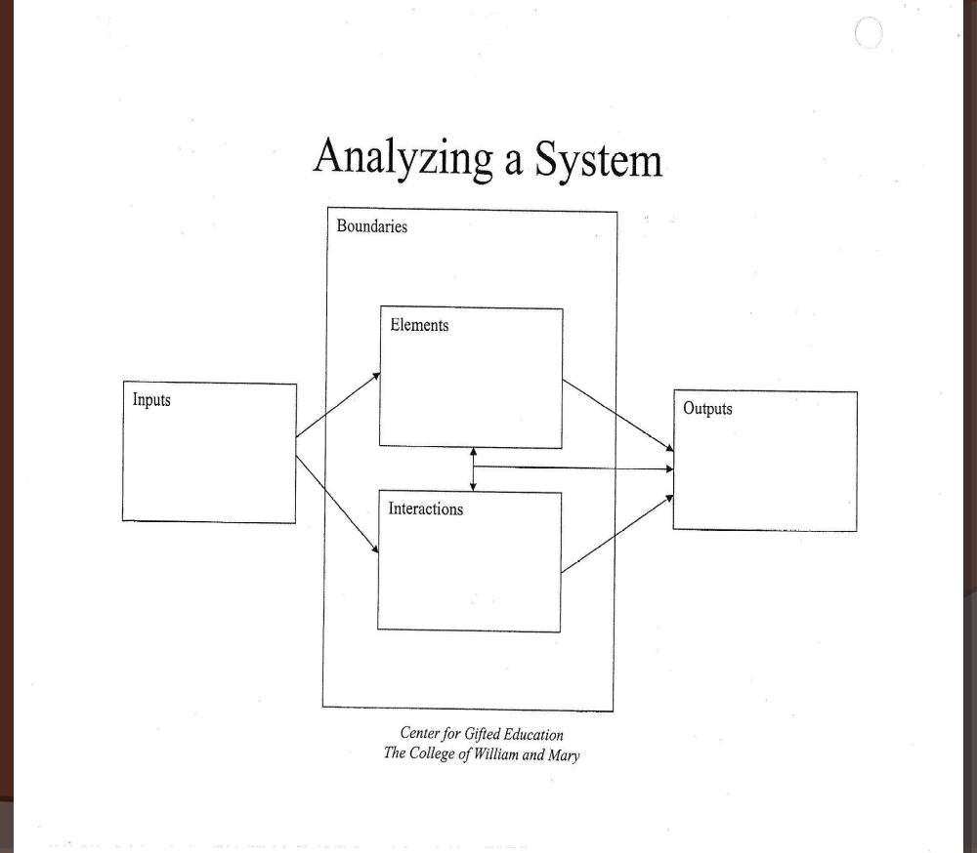

Score: ____
Pre-assessment: Computers as systems
SAMPLE
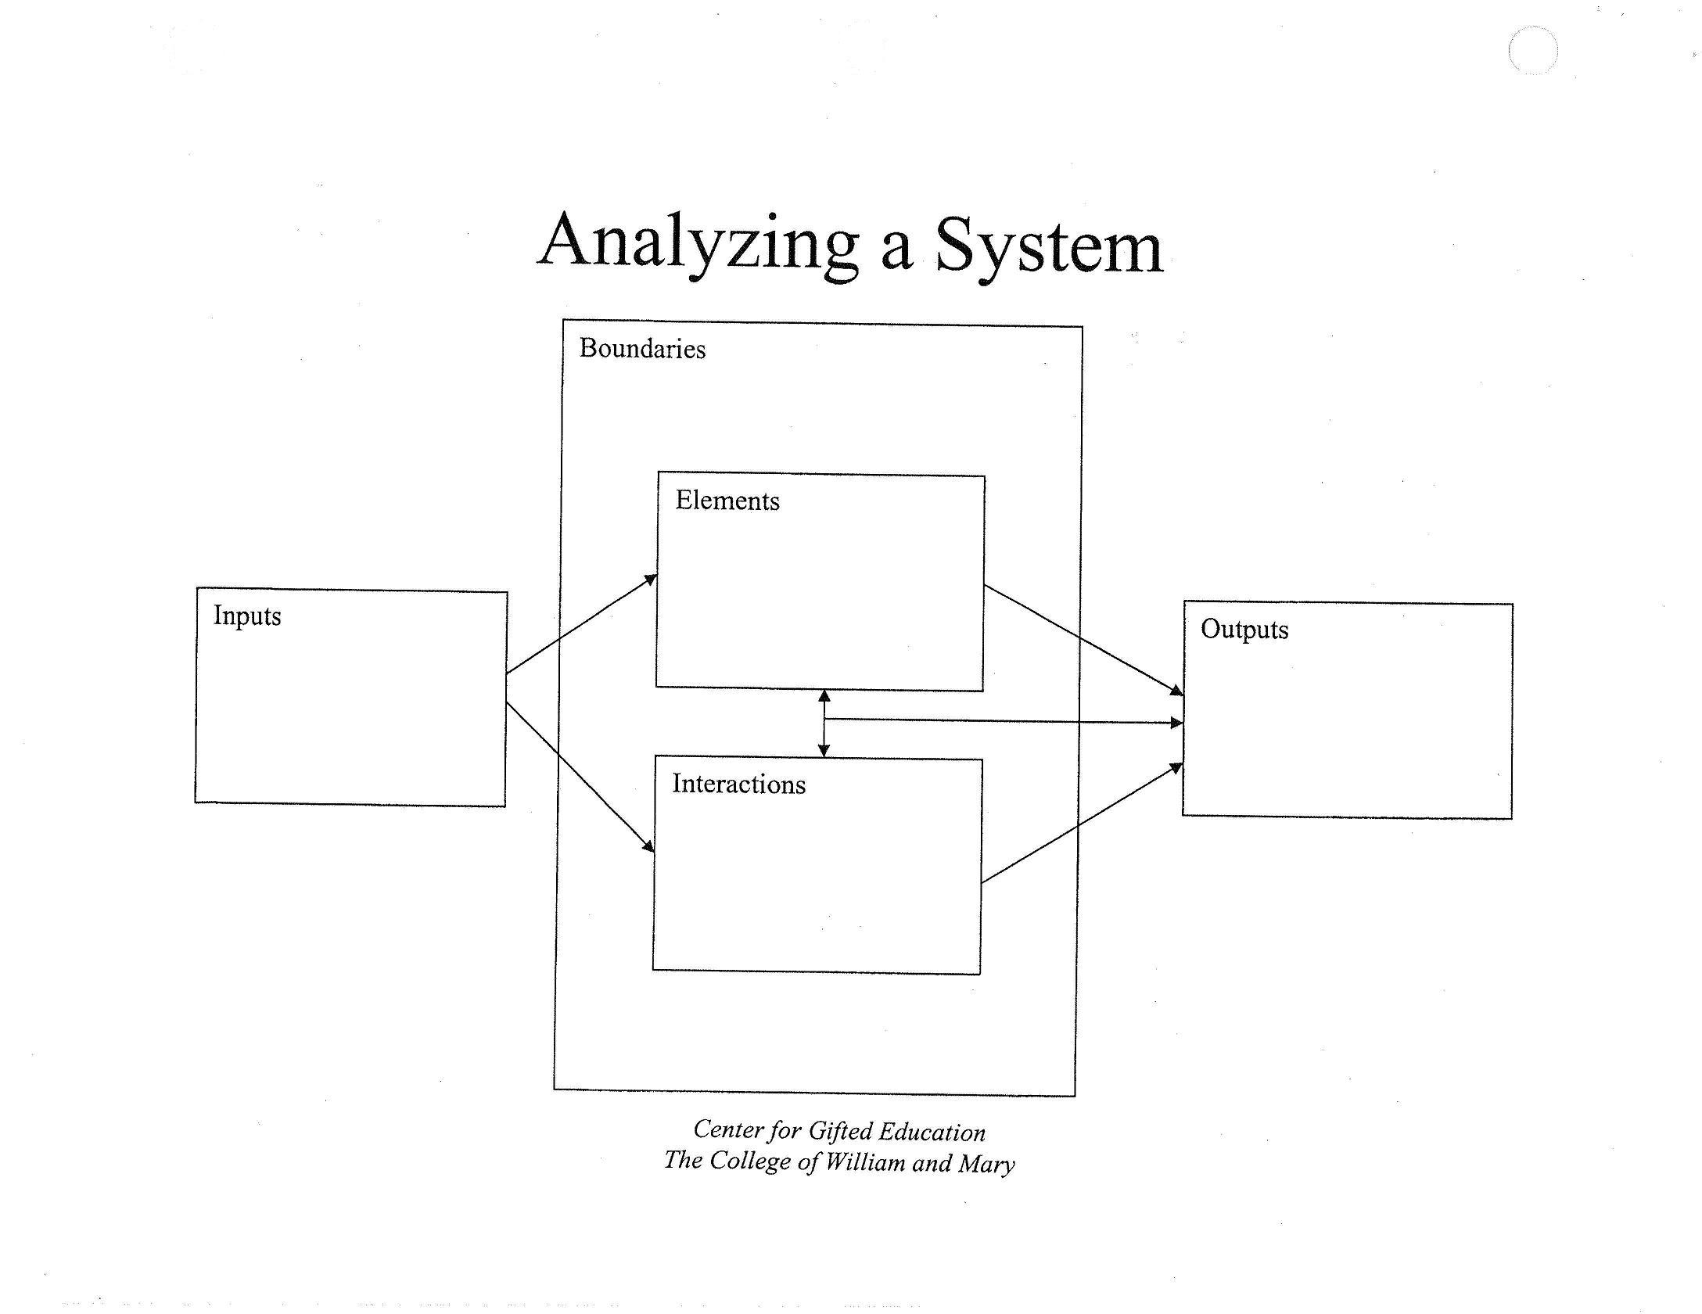
Analyzing a System
Thoughts, scanned and digital camera photos, Internet downloads, programs, data, information, software, innovation
E-mail, Web site, blog, documents, graphics, projector, robotics program, design
Internet connected devices and people, plastic box, limits of software/hardware, imagination
Keyboard, mouse, monitor, software, Internet connection, operating system, peripheral devices, power cord
Typing, programming, reading, viewing, downloading, listening, designing, creating graphics, editing, revising, learning
Teacher note: This is only a sample and should not be used as an answer key. There are many other possible answers.

Scoring:
Give students 1 point for every response that fits in the category in which the student wrote it.
Give students ½ point for every response that you are unsure of the best category. Note that some items may belong in more than one category (e.g., software may be an input, an output, a boundary, an element, and—when a student creates or works with software—an interaction).
Give students no point for any response that does not fit in the category in which the student wrote it.

Total the points for each student, writing their score in the correct location. There is no maximum possible score (no ceiling).

Four Analyzing a System assessments will be given, one each in challenges 1, 3, 7, and 10.

Once complete, the pre- and post-assessments can be compared to show student growth.

Name: ___________________
Date: __/__/____
Storm water as a system
(use with challenge 3)
Please complete the following graphic organizer to the best of your ability to show how storm water work as systems.

Score: ____
Name: ___________________
Date: __/__/____
The Earth as a system
(use with challenge 7)
Please complete the following graphic organizer to the best of your ability to show how the Earth work as a system.

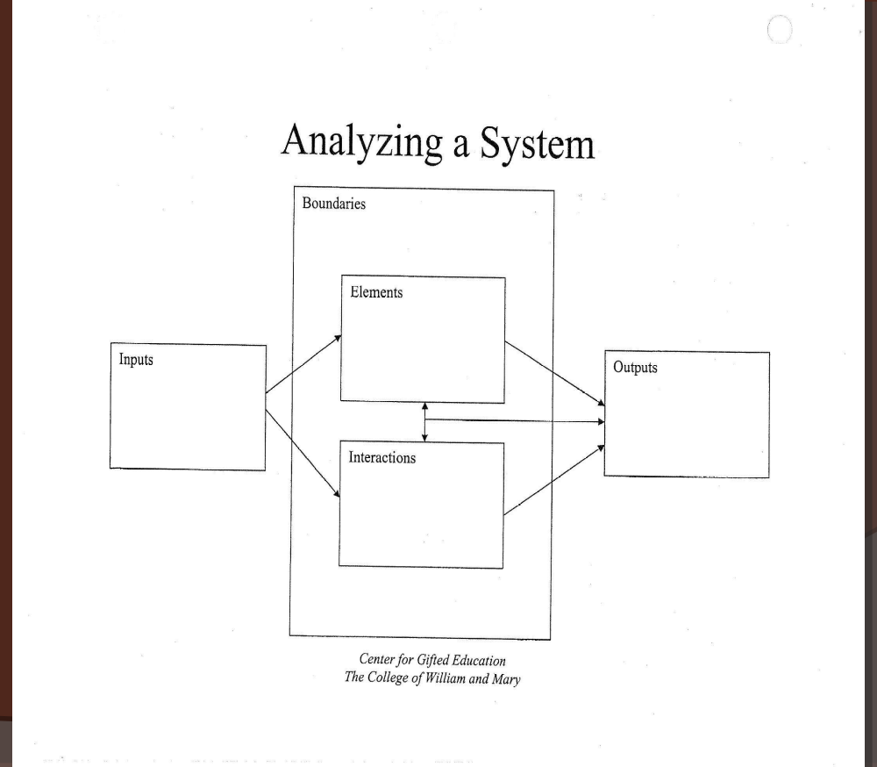

Score: ____

Name: ___________________
Date: __/__/____
Post-assessment: The human body as a system
(use with challenge 10)
Please complete the following graphic organizer to the best of your ability to show how the human body works as a system.

Score: ____

Robot design rubric Name: ________________
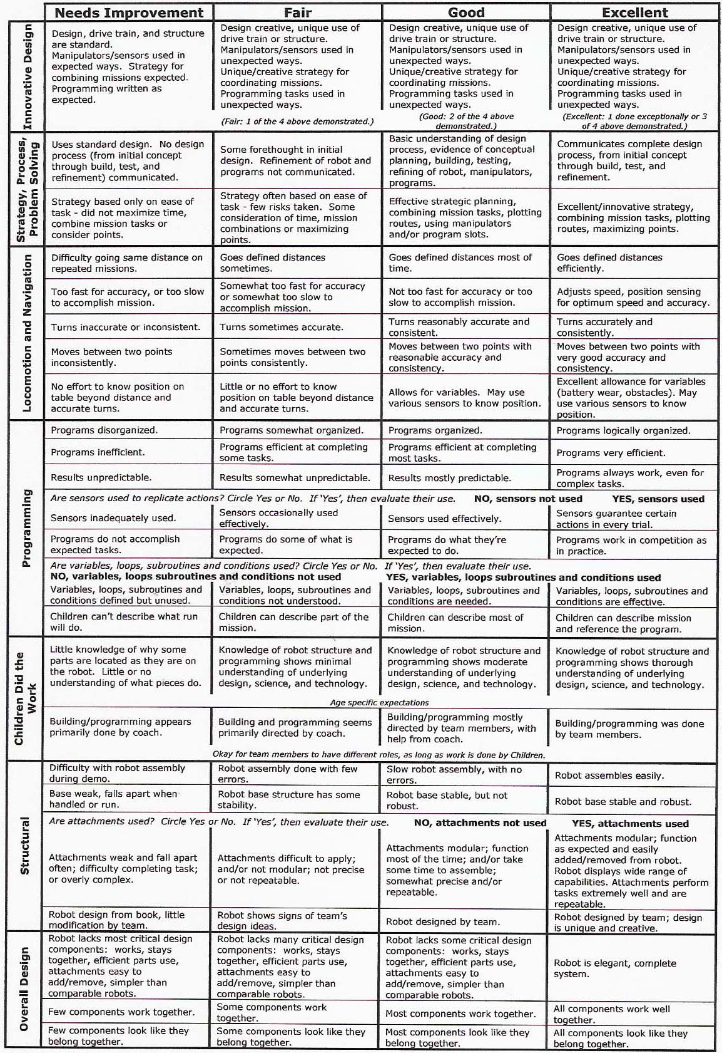
from the FIRST LEGO League Judges’ handbook
Score: ____
Scoring the Robot design rubric
The Robot design rubric should be used at the end of Challenges 1 and 10. It may be used by the teacher at any time to see how students are progressing and to frame student feedback in constructive ways. Nothing that the rubric scores is a secret: Students should be engaged in a discussion about what they are excelling at and what they need to improve upon. Students may also be asked to rate themselves on the rubric after a challenge and then to compare their results with that of the teacher’s.

The teacher should work with each student individually to have them explain and demonstrate their design, engineering, and programs.

To score:
Give 2 points for each “Excellent” circled.
Give 1 point for each “Good” circled.
Give ½ point for each “Fair” circled.
Give 0 points for each “Needs improvement” circled.

Write the total score on each student’s rubric. Be sure to save all pre-assessments until the end so that they can be compared with the post-assessments to show learning.
Name: ________________
Date: __/__/____
Six Thinking Hats Pre-assessment

Scenario: You and your younger brother have a pet hamster that is missing. The hamster lives in a glass aquarium with a wire top. The glass is unbroken and the top is on securely. Write down everything you know and feel about the situation and then create all of the questions that you might need an answer to in order that you find your hamster.

__________________________________________________________________________________________________________________________________________________________________________
__________________________________________________________________________________________________________________________________________________________________________
__________________________________________________________________________________________________________________________________________________________________________
__________________________________________________________________________________________________________________________________________________________________________
__________________________________________________________________________________________________________________________________________________________________________
__________________________________________________________________________________________________________________________________________________________________________
__________________________________________________________________________________________________________________________________________________________________________
__________________________________________________________________________________________________________________________________________________________________________
__________________________________________________________________________________________________________________________________________________________________________
__________________________________________________________________________________________________________________________________________________________________________
__________________________________________________________________________________________________________________________________________________________________________
__________________________________________________________________________________________________________________________________________________________________________
__________________________________________________________________________________________________________________________________________________________________________
__________________________________________________________________________________________________________________________________________________________________________
__________________________________________________________________________________________________________________________________________________________________________
__________________________________________________________________________________________________________________________________________________________________________
__________________________________________________________________________________________________________________________________________________________________________

Score: 0 1 2 3 4 5 6
Name: ________________
Date: __/__/____
Six Thinking Hats Post-assessment

Scenario: Every morning your neighbor turns the coffee maker on, then turns the other way to put some bread in the toaster. When she turns back to pour her coffee, the pot is always empty. The pot doesn’t have any holes in it. Write down everything you know and feel about the situation and then create all of the questions that you might need an answer to in order that you could solve the mystery of the missing coffee.

__________________________________________________________________________________________________________________________________________________________________________
__________________________________________________________________________________________________________________________________________________________________________
__________________________________________________________________________________________________________________________________________________________________________
__________________________________________________________________________________________________________________________________________________________________________
__________________________________________________________________________________________________________________________________________________________________________
__________________________________________________________________________________________________________________________________________________________________________
__________________________________________________________________________________________________________________________________________________________________________
__________________________________________________________________________________________________________________________________________________________________________
__________________________________________________________________________________________________________________________________________________________________________
__________________________________________________________________________________________________________________________________________________________________________
__________________________________________________________________________________________________________________________________________________________________________
__________________________________________________________________________________________________________________________________________________________________________
__________________________________________________________________________________________________________________________________________________________________________
__________________________________________________________________________________________________________________________________________________________________________
__________________________________________________________________________________________________________________________________________________________________________
__________________________________________________________________________________________________________________________________________________________________________
__________________________________________________________________________________________________________________________________________________________________________

Score: 0 1 2 3 4 5 6
Scoring the Six Thinking Hats pre- and post-assessments

Collect student’s work when they are finished. The scenarios are designed so that most students will understand the problem and are off-topic to ensure that students’ improvement in using the Six Thinking Hats (or other problem-solving method) is being measured, not an increase in STEM knowledge or other area. The goal is not to find one correct answer, but to list everything that is known and felt about a problem, and then to ask questions to eliminate options, hone down the possibilities, and creatively generate ideas. For example, in the pre-assessment, a student may write:

I know that the aquarium is not broken and that the wire top is on. I know that hamsters like to climb and chew, but it doesn’t seem like it got out that way. I have a little brother. I have a feeling that he may have the hamster. I need to know if there is anyone else that might have the hamster. Does my mom like hamsters? Could a burglar have broken in and taken the hamster? Is there a cat in the house? If the hamster is loose in the house, where would it go? I know hamsters like warm, comfortable places. He could be hiding in the wall like a mouse or in the couch.

Score the assessments by giving students one point for each Thinking Hat they use (0 minimum, 6 maximum). For example, the above response would earn 1 point for listing facts (white hat), 1 point for listing a feeling (red hat), 1 point for listing the negative aspect of a burglar (black hat), 0 points for not listing an obviously positive view (yellow hat), 1 point for listing creative possibilities (green hat), and 0 points for not organizing the thoughts (blue hat). This would give the student a combined score of 4/6. Teachers should use the pre-assessments to tailor their instruction on the Six Thinking Hats.

Alternatively, the assessments could be scored by giving one point for every problem-solving oriented thought generated.

Be sure to save the pre-assessment so that it can used to evaluate student learning with the post-assessment.
Resources

Websites

The Center for Gifted Education at The College of William and Mary: Creators of high-powered curriculum for gifted learners
http://cfge.wm.edu/

Edward de Bono’s official Web sites: The Six Thinking Hats developer offers many other resources
http://www.debonogroup.com/
http://www.edwdebono.com/

Engineering TV: Created by engineers for engineers, this site includes video on all aspects of engineering (including LEGO)
www.engineeringtv.com
F.I.R.S.T.: Creators of the FIRST LEGO League competition
http://www.firstLEGOleague.org/

LEGO: The company’s Web site offers a wealth of ideas (and fun games)
http://www.LEGO.com/eng/

LEGO education store: Order LEGO NXT and other educational LEGO products here, including curriculum
http://www.LEGOeducation.com/Default.aspx

LEGO engineering: Including free curriculum, this is a fantastic site for teachers of gifted students
http://www.LEGOengineering.com/

LEGO Factory: Design your own LEGO models and order your custom design
http://www.LEGOfactory.com

LEGO Portfolio: One man’s videos of his amazing LEGO robotics inventions
http://www.ericharshbarger.org/LEGO/portfolio.html

Mindstorms Robotics: Teachers and students may find design ideas and building plans here
http://mindstorms.LEGO.com/eng/default.asp

Odyssey of the Mind: This academic challenge also involves students in creative problem solving
http://www.odysseyofthemind.com/

O*Net: This Site offers a wealth of detailed career information, including within STEM
http://online.onetcenter.org/

Resources (cont.)

Books

Boogaarts, M., Daudelin, J. A., Davis, B. L., & Kelly, J. (2007). The LEGO Mindstorms NXT idea book: Design, invent, and build.

de Bono, E. (1999). Six Thinking Hats.

de Bono, E. (1994). Teach Your Child to Think

Kelly, F. K. (2006). LEGO Mindstorms NXT: The Mayan adventure.

Kelly, F. K. (2007). LEGO Mindstorms NXT-G programming guide.

Perdue, D. J. (2007). The unofficial LEGO Mindstorms NXT inventor’s guide.

Glossary
Challenge set: The mat and LEGO objects that accompanies each challenge.

Challenge aspect: A specific piece of the challenge.

Engineer (Used primarily as a verb in this unit): The designing and building of robots by students.

Field: The area on which a robot operates, usually a 4’x8’ table with a raised, black edge to prevent the robot from falling and to allow the use of sensors (touch, ultrasonic, and/or light) to detect the edge. The field should simulate real-world situations in which robotics may be used and can vary in complexity to challenge gifted learners. Fields may include Mars or deep sea exploration, a body outline for surgery, a challenging cityscape to navigate as a handicapped person benefiting from robotics.

NXT: The product name of LEGO’s second release of its Mindstorms Robotics kit

NXT-G: The programming language for the NXT robot, created on a computer and downloaded to an NXT robot via a cable or through a Bluetooth device.

Program: In this case, a set of instructions created by a programmer on a computer and downloaded to a robot to perform a specific task or tasks.

Programmer: In this case, the student or students who write programs as a set of logical steps for downloading to a robot to perform a specific task or tasks on a field.

Robot: A mechanical device that performs human-like tasks on command by being programmed in advance. In this case, LEGO NXT Robotics are used.

Sensor: Part of a robot that provides input and may affect the operation of a program. In this case, there are five sensors: 1) rotation, which measures the distance a motor has moved; 2) light, which measures the light reflected from objects or the field; 3) touch, a button than is either pressed or unpressed; 4) ultrasonic, which measures distance to a wall or large object; and sound, which measure the volume of noise. (Notably, sound sensors are not allowed in competition.)

STEM (as in Careers/Disciplines/Subjects): a common acronym standing for Science, Technology, Engineering, and Math.

